Drawing with Variables 2 Worksheet Name:_______________________________

Some of the problems below are best answered using REPEATS.

Answer the following questions using Scratch. Use the following script to clear the stage and reset the sprite after each question.

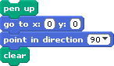
You are going to draw a flower.

- Run this script, and draw the picture it makes.

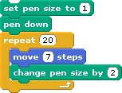

- Now, add to the script above so that it draws the same picture AND the sprite returns to the starting point. (See the picture below.) Draw your new script below. (Hint: you will need to lift the pen back up and reset the pen size.)
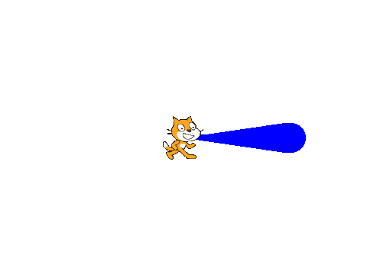

- Now change THAT script to make something that looks more like a flower with many petals. Draw your new script below. (Hint: The sprite will need to lift up the pen, change the pen size back to 1, and return to the starting point after drawing each petal.)

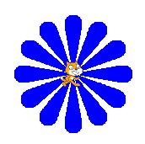

- LAST!!! Change the script above so that each flower petal is a different color! Draw your script below. (Hint: this block may be helpful: !)

Exit Question: To get full credit on this assignment, make sure to COMPLETELY answer the Exit Question below.

