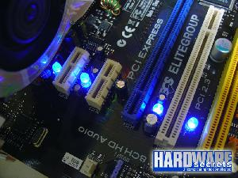
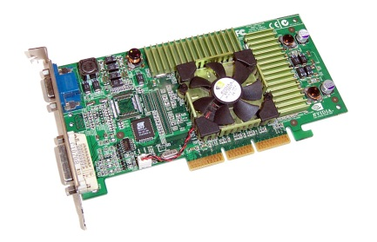
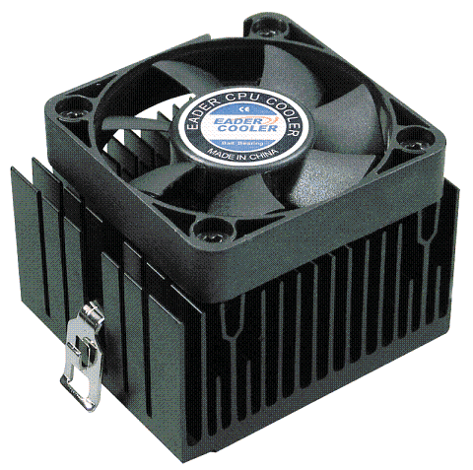
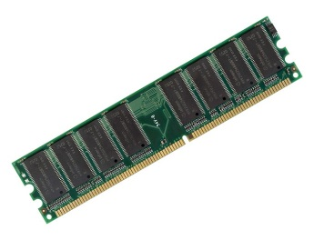

A B C D
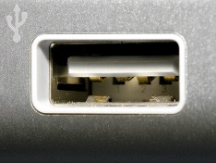
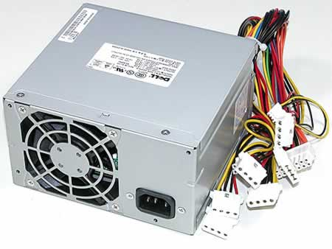
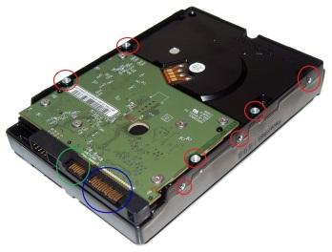
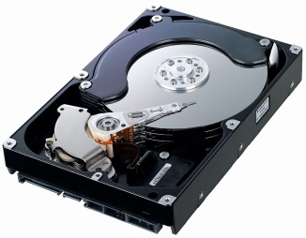

E F G H
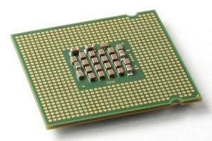
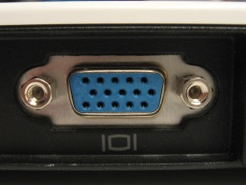
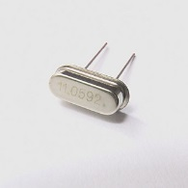
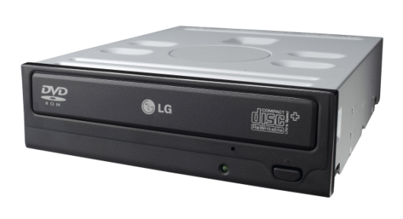

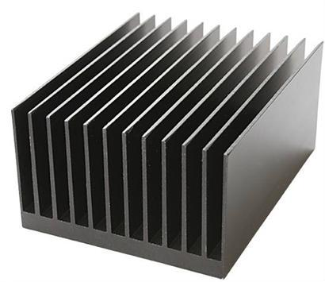
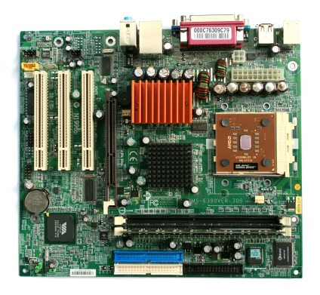
I J K L
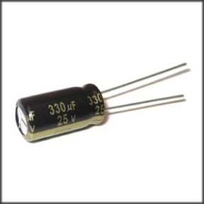
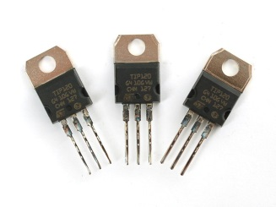

M N O P
Matching,
Match the letter of the picture to its name.
_____Cooling Fan ______CPU _____Graphics card _____Hard Drive

_____Heat Sync ______Motherboard ______RAM _____Optical Drive

_____Power Supply _____USB port

Definitions
Match the number of the word to the definition.
______Keeps the computer at an even temperature. Keeps it from melting down.

Word Bank
- Cooling Fan
- CPU
- Graphics Card
- Hard Drive
- Heat Sync
- Motherboard
- Optical Drive
- Power Supply
- RAM
- USB Port

______The Brain of the computer. Handles most of the Systems input.
______Where peripherals can be plugged in. Charges, connects, and does data transfer.
______Circuit board that connects the main parts of the computer. Backbone.
_____Converts information from the CPU to actual images.
______Loads information from CD’s, DVD, and BlueRay. Can Write things back on them.
_____Permanently stores information saved to the computer.
_____Helps distribute air to keep a computer chip, such as the CPU, cool.
_____Temporarily stores information while computer is on. Provides faster data access.
_____Converts AC (alternating current) to DC (Direct Current), so the computer will work.

Extra Credit. Write the picture letter and definition to the word.
____LED _______________________-_________________________________________________________________
____Transistor____________________________________________________________________________________
____Capcitor______________________________________________________________________________________
____Crystal Oscillators______________________________________________________________________________
____VGA Port_____________________________________________________________________________________

