Results of EEE Fall 2004 Research

Using Robot Platforms to Enhance Concept
Learning in Introductory Computer Science Courses

Dr. Colleen E van Lent
Computer Engineering and Computer Science

1. Statement of Need

A common pedagogical challenge in introductory courses is how to engage student interest without exceeding the limits of what can or should be expected from students learning basic concepts. This is true in CECS 174: Programming and Problem Solving I, an introductory course offered by the Computer Engineering and Computer Science Department. Many students believe that earning a degree in the field of computer science simply involves learning one, possibly two programming languages. In addition, a large number of students enrolled in the class are not computer science majors, and are not familiar with traditional computer science teaching approaches. Therefore, instead of striving to fully grasp the basic concepts of computer science, students mass produce code to get each specific assignment done. This practice fails to nurture the problem-solving skills necessary for ongoing career success, regardless of their field of study.

To further exacerbate this problem, it is extremely difficult for instructors to develop interesting assignments that only use concepts within the scope of introductory courses. Since the instructors are bound by this constraint, many assignments in the introductory courses rarely culminate in anything more than a display of alphanumeric values on a computer monitor. Because these assignments are typically artificial, students do not always recognize that these basic concepts have applications to larger problems. Instructors need a new approach to teaching 174. One way to provide the instructor and student with a “real world” setting is to incorporate a robotic platform. Hopefully, platforms that can sense and move (as opposed to textual I/O used with typical programming assignments) will provide a more active learning environment and promote student interest. The EEE award money was used to construct Lego robot platforms as tools for problem solving and programming. The goal was to use physical models as a motivation for understanding the underlying problem-solving concepts and develop a deeper understanding of programming constructs.

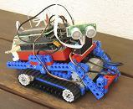

2. Project Goals

The goal of this project was to create a classroom environment that is conducive to demonstrating how simple concepts can be used to tackle large-scale problems. The two main tasks to realizing this environment were to :

- Develop a new set of introductory programming assignments that challenge the students to use problem-solving skills to solve real-world problems using a scientific design. These assignments had to be applicable to both traditional and robotic-platform enhanced learning environments.

- Develop tools that will allow other instructors to incorporate the platforms into their classrooms without the need to modify their students’ work.

It is important to note that there was never any intention to transform CECS174 into a robotics course, nor is there now. The students learned about the importance of functionality, passing proper inputs, and receiving expected output. The robots are used to create a more immersive environment.
3. Results

I have now completed my second semester of using robots in the course. In that time I have come to realize the challenges of maintaining a lab with no addition forms of maintenance support. Luckily, students outside the course took a great interest and provided their services as I will describe below. The funding provided allowed me to purchase the building blocks necessary to construct and maintain a small, mobile robot labs within our department. To date we have eight(8) fully functioning robots being used. These robots are being used to provide students with a novel, team-building environment in which to learn. While other instructors have yet to utilize these robots, I have now completed a primer and accompanying labs that I have distributed to the course coordinator and will also provide to all instructors next semester. The hope is that these tools will be used to enhance their own classroom experience, with minimal effort on their part. These documents are attached and were published as part of the “2004 American Association of Artificial Intelligence Spring Symposium: Accessible Hands-on Artificial Intelligence and Robots Education,” Stanford University, March 2004.

Additional Benefactors
The goal of the work proposed was to create a better learning environment for introductory computer science students. However, I feel it is justifiable to note that the usefulness does not end in that classroom. There are numerous other groups that have benefited from the creation of a mobile robotics lab in the CECS Department.

- Students in my graduate Artificial Intelligence course are using the materials to model the very topical problem of building a Mars Rover.
- The robots and modified versions of the labs have been used to great success as part of the Women at the Beach outreach program. I have also hosted individual high school groups at introductory robot programming tutorials.
- The Legos and motors were used as part of the CSULB Technology at the Beach summer camps.
- Perhaps, most surprising, there has been a strong demand for Friday robot labs. In a mutually beneficial relationship I provide a lab, some robots (and a little pizza) to students in exchange for their time constructing and maintaining the robots.

Appendix A: The Robot Team

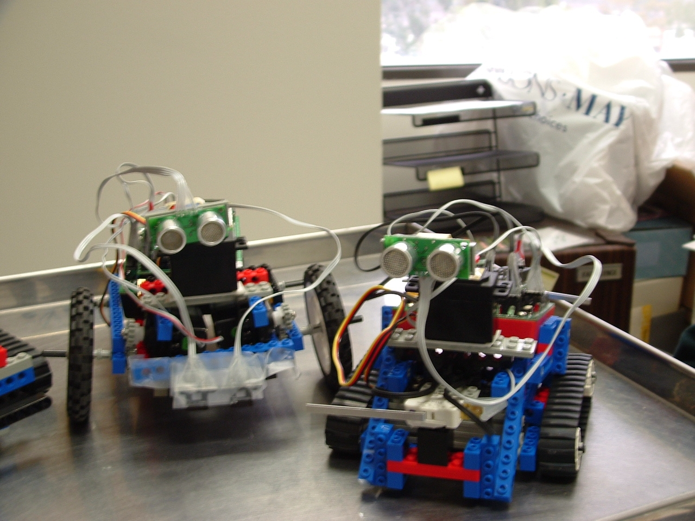

The robot on the left is equipped with both two infrared sensors for line following and a sonar for people tracking. The robot can follow a curving black line across a room with infrareds. The sonar is used to follow a person across a room; if the person speeds up, slows down, stops or goes backward the robot will mimic the action. The robot on the left is also equipped with a sonar, and has front and back digital sensors that act as bumpers. It can perform the same person following tasks or it can be used as a "ping-pong" robot -- traveling forward until it runs into an obstacle and then reversing until it hits an obstacle.
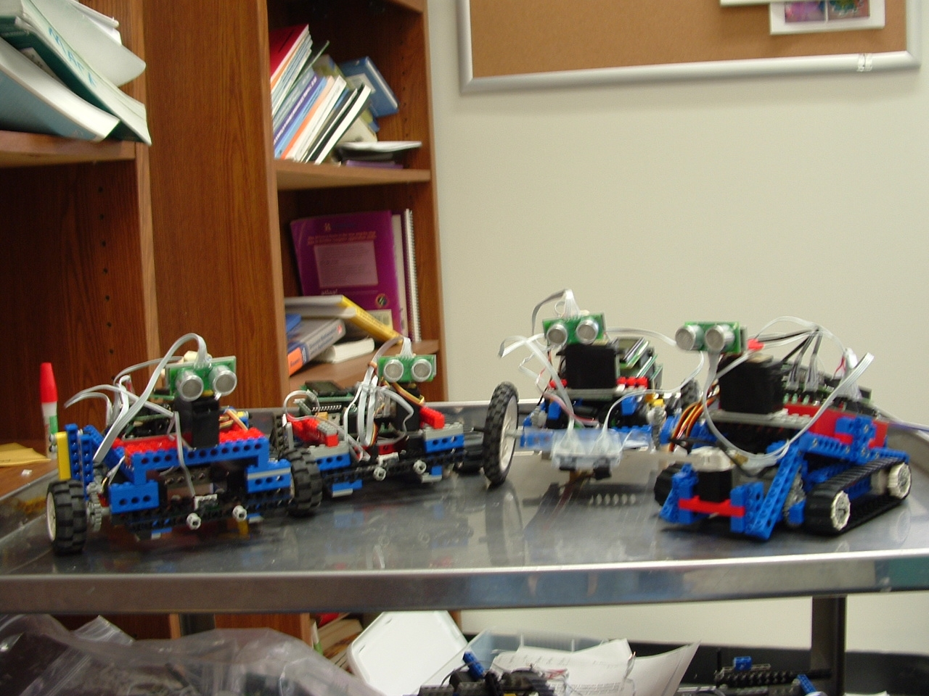

Part of our robot team. These four robots are all constructed of Legos, motors, digital, analog, and sonar sensors. The power and commands are all stored on a Handyboard Microprocessor.

Appendix B

Primer and Lab Assignments
Robot Primer
The robots use interactive C, which is very similar to C++. The main differences are:
- You do not have the lines
#include <iostream>
using namespace std;

- Printing to the screen is different
printf(“This is a string\n”);
printf(“This is a string that prints the value of an integer variable. The value is
%d”, variable1);
printf(“This is a string that prints the value of a double variable. The value is %d,
variable2);
printf(“This is a string that prints the value of a char variable. The value is %c,
variable3);

- The main function is of type void;

Important functions that are built in:
void motor(int a, int b); // Turns motor a on at power/speed b
int digital(int a); //Returns the value of the digital sensor plugged into port a
int analog(int a); //Returns the value of the analog sensor plugged into port a
int start_button(); //Returns the value of the start_button();
int stop_button(); //Returns the value of the stop_button();
ao(); // Turn off all motors
sleep(double a); // Wait a seconds before going to next line of code
beep(); // computer will beep
int knob(); // Returns the value of the knob – 0 .. 255;
int sonar(); // Returns value of the sonar

start_button(), stop_button() – return values of 0 or 1
digital(x) – returns value of 0 or 1. x can be number between 7 .. 15;
Your front bumper is plugged into port 15. Your back bumper is plugged into port 7;

analog(x) – returns value between 0..255. x can be number between 0..6
Your front analog sensor is plugged into 6. Your back analog sensor is plugged into 0

motor(x,y) – x can be 1..4; y can be -100..100;
Your right motor is plugged into port 3. Your left motor is plugged into port 1.

**Important**
1) Ending a function does not turn a motor off. The only way to turn a motor off is to use the function ao() or motor(x,0);

2) If your wheel goes forward when you thought it would be backward, it is plugged in backward. GENTLY unplug it and turn it 180 degrees. Ask for help the first time.
Robot Lab One
Using functions

Objective: Develop a degree of comfortableness using built-in, or predefined, functions.
Goal: Write a number of programs that will implement simple tasks using only built in functions.

- Write pseudo code for the following problems.
- Write and test your code afterwards and indicate where you had to deviate from your original ideas in 1). In the event your robot falls apart (kind of likely) work on the labs that are due on Tuesday.

Tasks
- Make the robot go forward;
- Make the robot go backward;
- Make the robot go forward ~2 feet and then go backward ~1 foot without any interaction with a person. Make sure to write down if you had to do any testing to get this to work.
- Make the robot wait to go forward until you signal it to start by pressing the start button. The robot should beep while it is waiting to start and display the message “Press start to begin.” Use this action in the next two problems too.
- Go forward until you hit the front bumper, and then go backward until you hit the back bumper. While going forward, display the message “Hit front bumper to go in reverse.” While going backward, display the message “Hit back bumper to stop.”
- Repeat behavior 4 until the user hits the stop button. (You may require the human to hold it for a few seconds. Obviously the messages should be different.
- Make your robot navigate a square.

If you do not finish all of these behaviors, don’t worry. Just hand in a piece of paper with all of your names describing your attempts. Any code should be saved to your z:\ drive. The best way to do that is for everyone to use the same computer. When you are done, open Internet Explorer and type:
ftp://www.heart.cecs.csulb.edu
It will ask for you user name and password. Then the other group members can drag the files to their directory.
I hope someone remembers to type ao() so I don’t do a flying leap off this cliff

Robot Lab Two
Using sensors as input

Objective: Become familiar with sensor capabilities and then use problem-solving skills to interpret sensor values as input to your program.

Goal: Control the robot using the four “sensors” as input: the start button, stop button, front bumper, and back bumper. In this and in all future labs the robot should not move until the start_button is pressed. Then the robot must travel forward until the front bumper is hit and then backwards until the back bumper is hit, i.e., bouncing back and forth (repeatedly). Stop moving when the user hits the stop_button. Repeat the program every time the user hits the start_button.

A. Fill in the possible values returned by these functions. Use a range of 0..x.

Different inputs: Possible Values Function call
Digital sensors -- digital(port#);
Analog sensors -- analog(port#)
Start_button -- start_button()
Stop_button -- stop_button()
Sonar() -- sonar()
Knob() -- knob()

Your Tasks
- Write pseudo code for the following problem described above.
- Write and test your code afterwards and indicate where you had to deviate from your original ideas. I recommend using the beep command to help debug your program at run time.
- How can you adjust your code if one motor is more powerful than the other?
I am getting dizzy.

Robot Lab Three
Robot Detective

Objective: Improve problem-solving skills by (again) interpreting sensor values as input to your program.

Goal: Control the robot using the start button, stop button, and sonar sensor. In lab today the robot must “shadow” a person from your group – maintaining a constant 12 inches behind. Adjust your speed to the speed of the person and be prepared to go backwards

Your Tasks
- Create your shell algorithm: how main will run regardless of how the other functions are written –WRITE IT ON THE BOARD
- Agree on any constants.
- Once all of this is done, show my your written code. And then go to the lab to run it. I need to see your code before you go in the other room.
I feel I am being followed….

SHH!!

Important functions:
printf(“ blah, blah, blah\n”;
printf(“The sensor value is %d”, digital(1));
printf(“The sensor value is %d”, distance));

Robot Lab Four
Drunk and Disorderly Robot

Objective: Improve problem solving skills by interpreting the output of analog sensors and using the values to control the robot.

Goal: Your robot has been pulled over for suspicion of drunk processing. It is your job to program the robot to successfully follow a black line across the floor. Unfortunately, the person who put the tape down must have been out the night before too -- be prepared for a curvy line.

Steps
- Write pseudo code for the following problem described above.
- Write and test your code afterwards and indicate where you had to deviate from your original ideas. I recommend using the beep command to help debug your program at run time.
- What affect does your speed have on your results?
- What can you do to stop once you have reached the end of the line?

Use the interaction window to test the different values you receive for different colors.

Robot Lab Five
Using For Statements

Objective: Use iteration concepts, constants, built-in functions, and variable declarations to solve a robot task.

Goal: Write a program that will instruct the robot to “scan” the horizon with the sonar in search of nearby objects. Once a complete scan is done, the sonar should be pointed back to the direction of the nearest object. Repeat the program every time the user hits the start_button. Power down when the user hits the stop_button.

Robot

Steps
- Write pseudo code for the following problem described above.
- Write and test your code afterwards and indicate where you had to deviate from your original ideas. I recommend using the beep command to help debug your program at run time.
- How would you change your code to command the robot to travel towards the object once it is found?

New material for the lab
In this lab you will be using the servo motors. The servo motors consume a lot of power; therefore they require explicit power on/off commands. Use the command init_expbd_servos(1) to power the motors once the user hits start. Use init_expbd_servos(0) to power the motors off at the end of each iteration. Unlike the DC motors that control the speed and direction of your robots, servo motors rotate to a given direction rather than turn at a given speed:
motor(1,100); //Motor 1 at full power forward
servo5 = 2400; //Servo 5 to direction 2400
servo5 = RIGHT //Servo 5 to direction stored in RIGHT

Use the interaction window to find the furthest left and right directions of your servo motors. Then always stay slightly away from the edge. When writing your code, please remember that the processor executes commands quickly, quicker than the servo might be able to move. Include a short sleep() command between each move.

Important functions:
printf(“ blah, blah, blah\n”);
printf(“The sensor value is %d”, digital(1));
printf(“The sensor value is %d”, distance));

