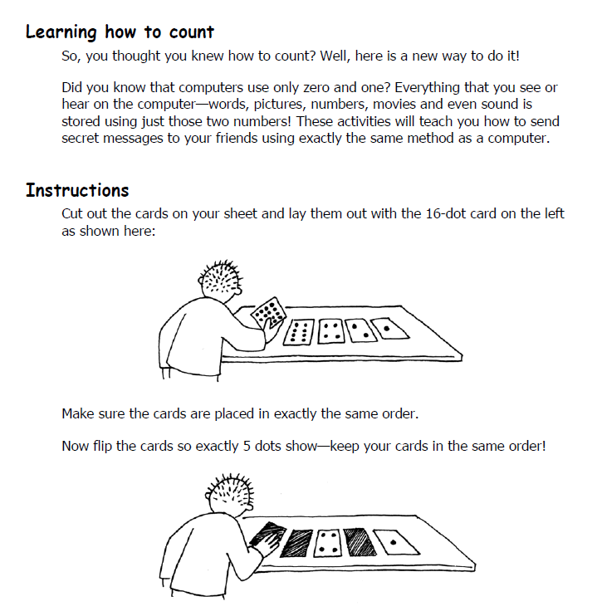

Questions:
- Draw what the cards look like when you make the numbers 3, 12, & 19.

3 –

12 –

19 –

- Is there more than one way to make any number? If yes, what number, and how can you make it?

- What is the biggest number you can make? Draw it below.

- What is the smallest number you can make? Draw it below.

- Is there any number you can NOT make between the biggest and the smallest numbers? If yes, what number(s)?

Challenge
Make the numbers 1, 2, 3, & 4 IN ORDER. (Make the number 1, then the number 2, etc.) Can you work out a good system for flipping the cards to increase ANY number by one? (From 1 to 2, or from 13 to 14, etc.) Explain your system below.

Using 1’s and 0’s

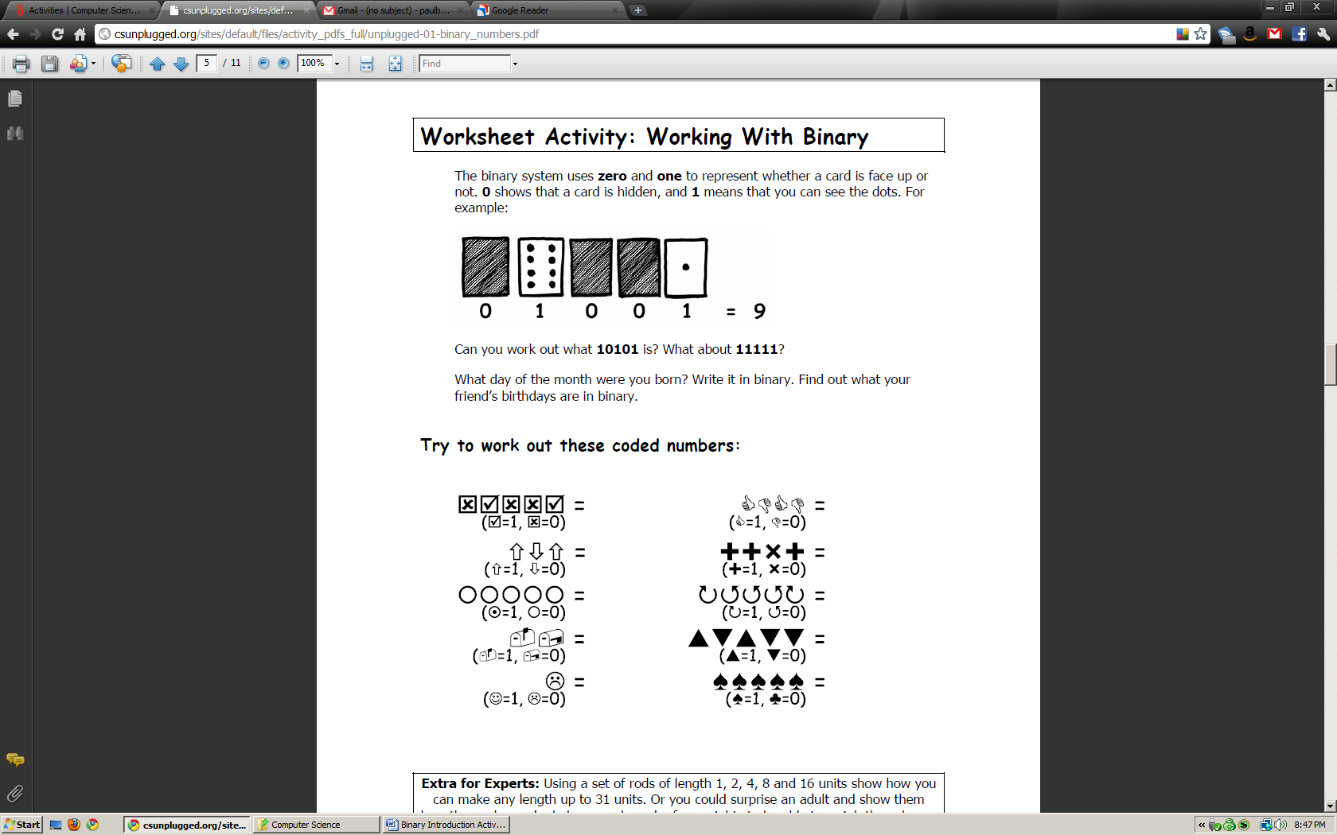

You Try:

What is 10101?________________ What is 11111?_________________

What number month were you born in?_________ What is that in binary?_________________

Now:
Write each number in binary

1 =
2 =
3 =
4 =
5 =
6 =
7 =
8 =
9 =
10 =
11 =
12 =
13 =
14 =
15 =
16 =
17 =
18 =
19 =
20 =
21 =
22 =
23 =
24 =
25 =
26 =
27 =
28 =
29 =
30 =
31 =

