Exploring Sounds in Scratch Worksheet Name:_______________________________

- What is a block?

- What is a script?

- How do you remove a block piece that is in the middle of a script?

- Fill in the blanks below that show the order in which the notes play in this script.

60 ___ ___ 62 60 62 ___ 62
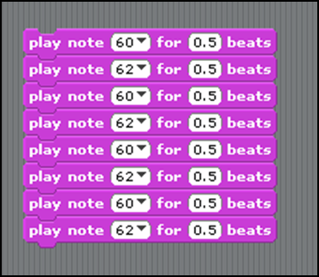

- Next to each of the scripts below, write the order in which the notes play.
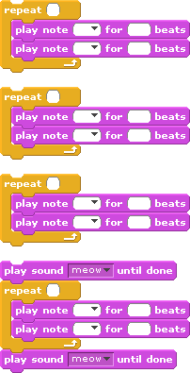

- Make a song using only these three blocks and repeats. At the end of class, we will share the songs we’ve made as a class.

