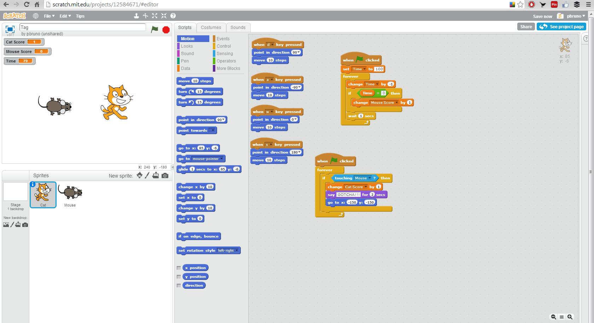
Introduction to Scratch Notes Name:________________________________________

