Notes and Repeats Worksheet Name:_______________________________

- What does the “play note” block do?

- What are the 2 things you can change on the play note block?

- What does the rest block do?

- What does the repeat block do?

Answer the following questions using Scratch

Write the following script in Scratch to answer questions 5 & 6.
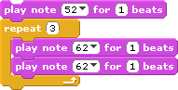

- How many times does the note 52 play when you run the script?

- How many times does the note 62 play when you run the script?

Write the following script in Scratch to answer questions 7 & 8.

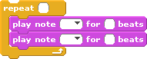

- How many times does the note 62 play when you run the script?

- How many times does the note 64 play when you run the script?

- Fill in the blanks below that show the order in which the notes play in this script.

60 ___ ___ 62 60 62 ___ 62
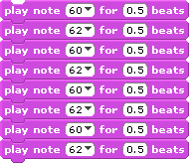

Write the following script in Scratch to answer question 10.

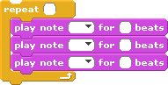

- How many times does the note 52 play when you run the script?

If you completely finish this worksheet, you may make songs in Scratch using ONLY the following blocks:

