Notes: Playing Notes and Repeats in Scratch Name:_____________________________________

Notes

The play note block plays a _________________ note. It has 2 ___________________:
- You can change the ____________.
- You can change how _____________ the note plays (in beats).

Rests

The rest block makes the script _____________. It has 1 variable:
- You can change how long the pause _____________ (in beats).

Repeats

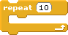

The repeat block tells the computer to do the same thing ________________________ again. It has 1 variable:
- You can change how many times to repeat the _______________ inside the repeat block.

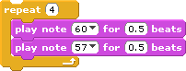

Other blocks can be placed _________________ the repeat block. Everything inside the repeat block will be repeated as many times as you want.

