Drums, Tempo, and Nested Repeats Worksheet Name:_____________________________

- What does the “play drum” block do?

- What are the 2 things you can change on the play drum block?

- What are 4 different drum instruments you can choose from using the play drum block?

- What does the “tempo” block do?

- What is a “nested repeat”?

Answer the following questions using Scratch

Write the following script in Scratch to answer question 6.
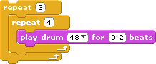

- How many times does the drum note 48 play when you run the script?

Write the following script in Scratch to answer questions 7, 8, & 9.

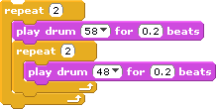

- How many times does the drum note 58 play when you run the script?

- How many times does the note 48 play when you run the script?

- Fill in the blanks below that show the order in which the notes play in this script.

58 ___ ___ 58 48 ___

If you completely finish this worksheet, you may make songs in Scratch using ONLY the following blocks:

