Setting and Changing Tempo & Volume Worksheet Name:__________________________

- What is the difference between the “set tempo” block and the “change tempo” block?

- What happens if you check the checkbox next to the “tempo” or “volume” blocks?

Answer the following questions using Scratch

Write the scripts below in Scratch to help answer questions 3-9.
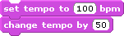

- What is the final tempo after running this script?___________________

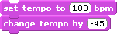

- What is the final tempo after running this script?___________________

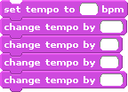

- What is the final tempo after running this script?___________________

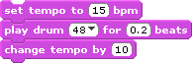

- What is the final tempo after running this script?___________________
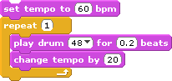
- What is the final tempo after running this script?___________________

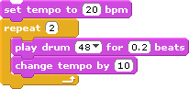

- What is the final tempo after running this script?___________________

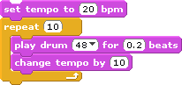

- What is the final tempo after running this script?___________________

Write the scripts below in Scratch to help answer questions 10-11.

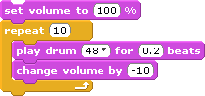

- What is the final VOLUME after running this script?____________________

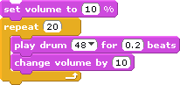

- What is the final VOLUME after running this script?_____________________

Finally…
- Do there seem to be any limits on how high or low you can get the tempo?

- Do there seem to be any limits on how high or low you can get the volume?

