Controlling Scripts with the Keyboard Worksheet Name:_______________________________

First, a brief variable review:

- Make a new variable, then make the following script in Scratch using your variable. You will use it to help answer the next questions.

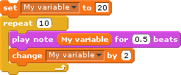

- Click on the tab to get the “looks” blocks. Change the block above to make the sprite count down from 10 to 0. Then draw your new script below. (If you did this yesterday, please do it quickly one more time.)

OK, now onto mapping scripts to the keyboard:

- What does the “when key pressed” block do?

- What does it mean to “map a key to the keyboard”?

Flip over to the back of this paper to continue.

Now practice mapping scripts to the keyboard:

- Use the “when key pressed” block to turn your computer keyboard into an electric keyboard. Your keyboard must do all of the following things:
  - It must be able to play every note from 48 to 72.
  - It must be able to change between at least 5 different instruments.
  - It must be able to control (increase AND decrease) the volume.
  - It must be able to control (increase AND decrease) the tempo.
  - It must be able to play at least 3 drum beats forever.

When your keyboard can do all of these things, have Mr. Bruno check it off.

You may want to use the images below to keep track of how you’ve mapped the scripts to the keyboard.

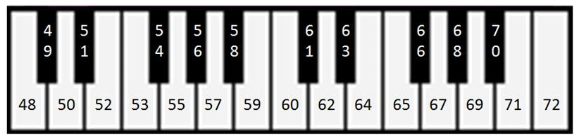

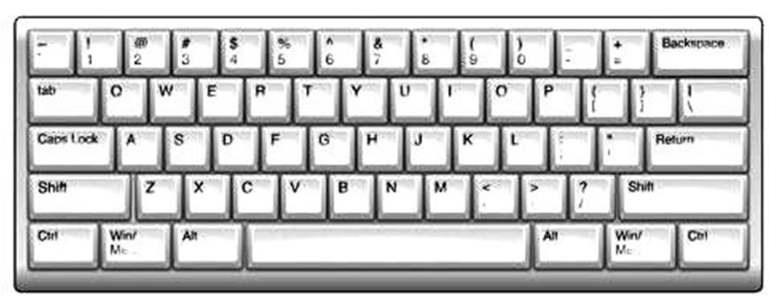

If you finish early, try mapping “Motion” commands to the keyboard (look in the “Motion tab).

