Notes: Position in Scratch Name:_____________________________________

Position on the Stage

In Scratch, the sprites perform the commands you give them on the __________________.
You can control the ____________________ of the sprites on the stage.

In Scratch, the stage is actually a big X/Y _____________________________________. Like a graph!

The position of the sprite is a combination of its position on the ______________ and its position on the _________________.

The x-axis (side to side) goes from __________ to __________.
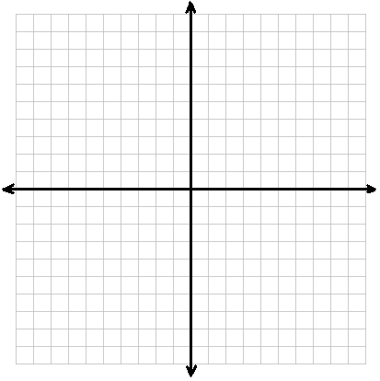
The y-axis (up and down) goes from __________ to __________.

To describe a position on the stage, give its _________________ on the x-axis followed by its position on the y-axis, in __________________________.

Example: ______________________

In Scratch, the sprite usually begins at the center of the stage. Its position is _______________.

Guided Practice:

- Estimate the sprite’s position:_________________

- Estimate the sprite’s position:_________________

- Estimate the sprite’s position:_________________

