Position in Scratch Worksheet Name:_______________________________

- Label the x-axis and the y-axis on the picture of the stage below.

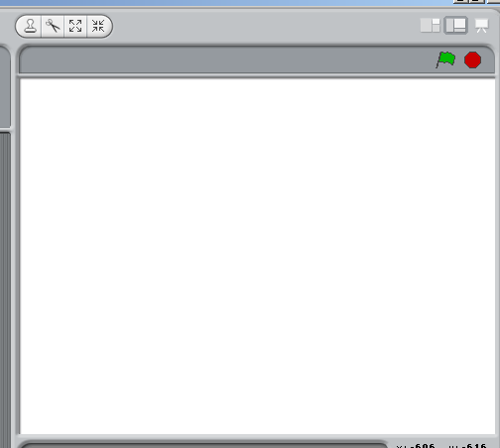

- On the picture ABOVE, label each end of the x-axis as “-240” and “240”. Then label each end of the y-axis as “-180” and “180”.

For problems 3-8, draw each shape at ABOUT the right position on the stage above.

- On the picture above, draw a small star at the position (0,0).

- On the picture above, draw a small dot at the position (240,180).

- On the picture above, draw a small circle at the position (-240,-180).

- On the picture above, draw a small square at the position (-120,90).

- On the picture above, draw a small triangle at the position (-120,-90).

- On the picture above, draw a small x at the position (100,-60).

Flip over!

- On the stage below, draw 10 dots. Label each dot with its position. An example has been done for you.

(-190,170)

- On the stage to the right, draw 3 dots and label each one with its position. (Can you do it without the x-axis and y-axis drawn in?)

