Notes: Motion in Scratch 1 Name:_____________________________________

Move

The move block makes the sprite move _____________________. It has 1 variable:

  - You can change how many ________________ the sprite takes.

The stage is ___________ steps wide (-240 to +240) and ____________ steps tall (-180 to +180).

The sprite will move in the direction it is ___________________.

Turn

The turn blocks make the sprite turn ________________________ or ________________________________. They each have 1 variable:
  - You can change how many ___________________ the sprite turns.

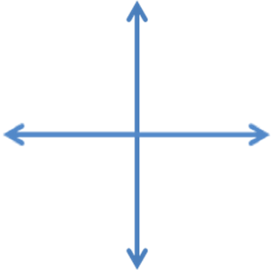
The sprite can turn _________ degrees.
- ____________________ – facing straight up
- ____________________– facing right
- ____________________– facing down
- ____________________– facing left (also -90)

Keeping track of position and direction

To keep track of the sprites position and direction, you can click on the ______________________ next to “x position”, “y position”, and “direction” in the Motion tab.

The sprite’s position and direction will then appear on the ___________________.

