Using the Pen 2 Worksheet Name:_______________________________

- What does the “set pen color” block do?

- What does the “set pen size” block do?

- What do the “show” and “hide” blocks do?

Answer the following questions using Scratch. Use the following script to clear the stage and reset the sprite after each question.

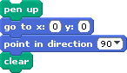
- Write a script to make the sprite draw a thick purple dashed line. (HINT: YOU SHOULD USE A REPEAT!) Draw your script below:
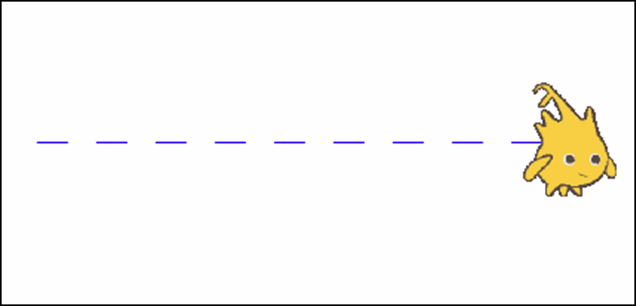

- Write a script to make the sprite draw a thin red staircase. (HINT: YOU SHOULD USE A REPEAT!) Draw your script below.
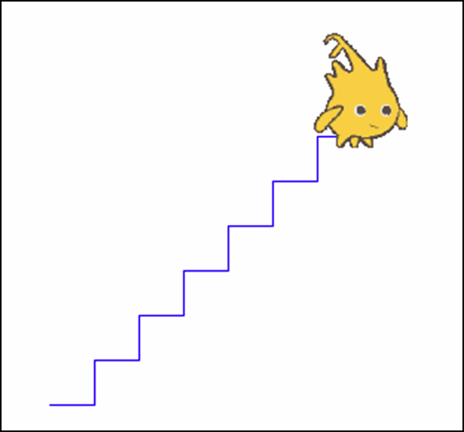

- Write a script to make the sprite draw a large, thick green circle. Draw your script below.

- Write a script to make the sprite draw a small, thin orange circle. Draw your script below.

