Notes: Drawing with Variables Name:_____________________________________

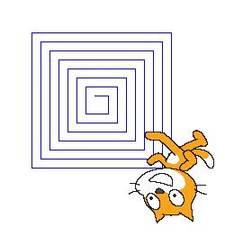
How to draw a squiral

A squiral is a combination of a _______________ and a ________________.

You could do draw a squiral in Scratch without using ____________________, but it would be hard.

If you think about the sprite moving to draw the squiral, you might notice that each time it moves, it moves a little __________________________.

What to do:
- Make a variable and give it a ________________ (like “length”).
- Add the variable to a “____________________________” block.
- Have the sprite put the ________________________.
- To draw the squiral, the sprite will have to walk, turn, then walk a little farther, then ________________ that process. So add your _______________ block, a _____________ block, and a “________________________________” block inside a repeat block.

Draw the final script below:

