Drawing with Variables Worksheet Name:_______________________________

Some of the problems below are best answered using REPEATS or VARIABLES.

Answer the following questions using Scratch. Use the following script to clear the stage and reset the variable and sprite after each question.

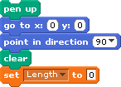

- Write the script we used to draw a squiral below.

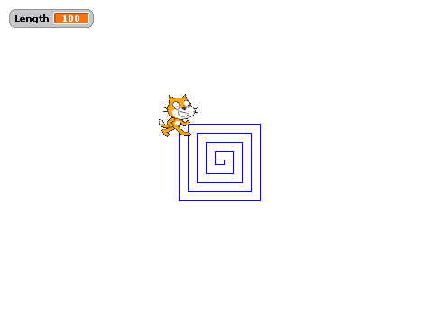

- Write a script to make the sprite draw a bigger squiral. Draw your script below:
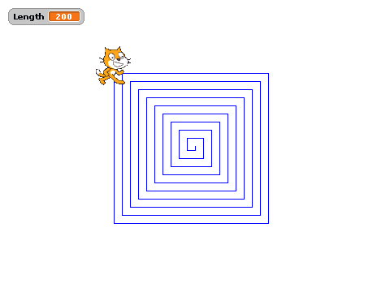

- Write a script to make the sprite draw a tighter squiral (where the lines are closer together). Draw your script below.
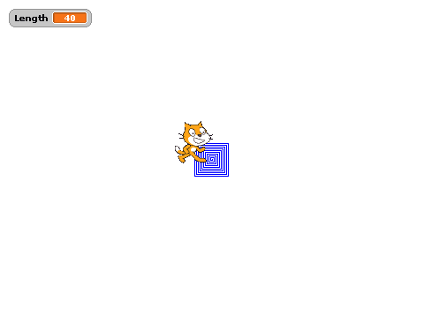

- Write a script to make the sprite draw a SPIRAL (round instead of square). Draw your script below. (It doesn’t have to be a perfect spiral.)

  - Draw the spiral you made.

- CHALLENGE! Below is a picture of 7 squares drawn inside each other. Write a script to make this picture and draw your script below. Here is a hint: have the sprite draw the smallest square first, and then make each additional square bigger and bigger. You will probably need to use repeats AND a variable.
