Drawing with Variables 3 Worksheet Name:_______________________________

Answer the following questions using Scratch. Use the following script to clear the stage and reset the sprite after each question.
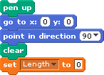
- Make a variable and name it “length”. You will need to use this variable in each question.

- Write a script to draw a squiral from the inside out. Draw your script below.
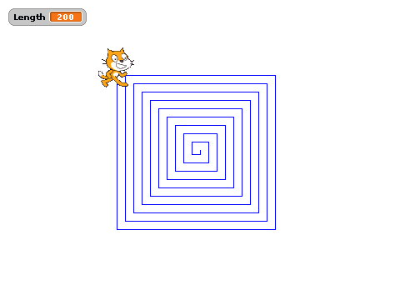

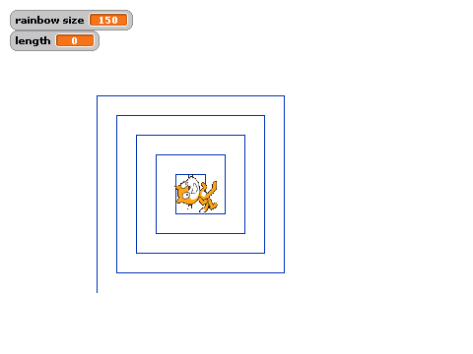
- Now, write a script to draw a squiral from the OUTSIDE IN. You should end up with something like the picture below. Draw your script below.

- Now, clear the stage and run the following script. Draw the shape it makes. (You may need to move or shrink the sprite to see the whole picture.) (We’ll call these “rectangular arches”.)
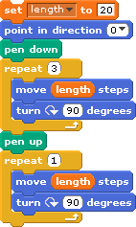
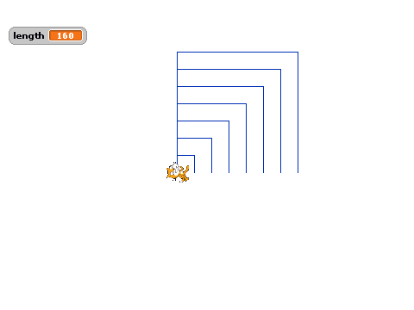
- Now change that script to draw 7 bigger and bigger rectangular arches that start from the same point. (Hint: You will need to change the variable by using AND you will need to use another repeat.) Draw your script below.

- Now change that script so that all of the lines are thicker. Draw your script below.
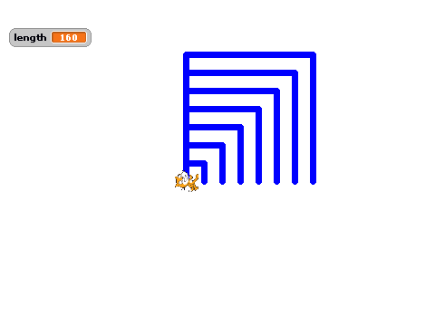

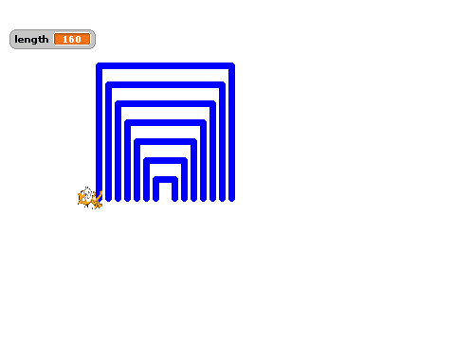
- Now change THAT script so that all of the rectangular arches are spaced evenly apart. (Hint: Use the block, and try different positive and negative numbers to get the arches spaced out evenly.) Draw your script below.

- Last, change THAT script so that each arch is a different color. That will make what Mr. Bruno calls a RECTANGULAR RAINBOW. (Hint: You should use the block.) Draw THE CHANGES to your script below.

Exit Question: To get full credit on this assignment, make sure to COMPLETELY answer the Exit Question below.

