Notes: Drawing with Coordinates Name:_____________________________________

Go to x y

The go to x y block makes the sprite move to the x and y _____________________ you provide. It has 2 variables:
- You can change the position on the _________________.
- You can change the position on the _________________.

If the sprite has the pen down while it moves, it will draw a line from where it ______________ to where it ___________________.

You may find it helpful to change the ________________________ on the stage by adding the x and y axes.

Notes: Drawing with Coordinates Name:_____________________________________

Go to x y

The go to x y block makes the sprite move to the x and y _____________________ you provide. It has 2 variables:
- You can change the position on the _________________.
- You can change the position on the _________________.

If the sprite has the pen down while it moves, it will draw a line from where it ______________ to where it ___________________.

You may find it helpful to change the ________________________ on the stage by adding the x and y axes.

If you don’t want the sprite to draw a line when it moves, you need to make sure to have it _________________________________.

Drawing a house with coordinates
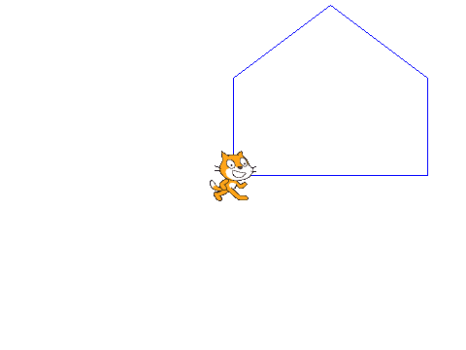
What to do:
- Have the sprite put the pen __________ and start at (___,___).

- Have the sprite move to (_____,_______).

- Have the sprite move to (_____,_______).
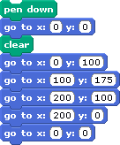
- Have the sprite move to (______,______).

- Have the sprite move to (_______,_____).

- Have the sprite move back to (_______,______).

If you don’t want the sprite to draw a line when it moves, you need to make sure to have it _________________________________.

Drawing a house with coordinates
What to do:
- Have the sprite put the pen __________ and start at (___,___).

- Have the sprite move to (_____,_______).

- Have the sprite move to (_____,_______).
- Have the sprite move to (______,______).

- Have the sprite move to (_______,_____).

- Have the sprite move back to (_______,______).

