Coordinates in Scratch Worksheet Name:_______________________________

Answer the following questions WITHOUT using Scratch.

For each question, draw the shape on the stage, then label each point, then draw the script you would use to draw that picture.

- Write a script to draw a square.

Picture (label each point!) Script
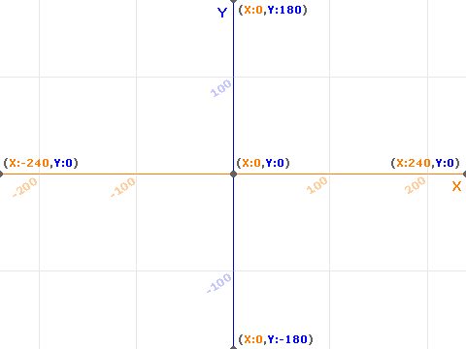

- Write a script to draw a long rectangle.

Picture (label each point!) Script

- Write a script to draw a triangle.

Picture (label each point!) Script

- Write a script to draw a parallelogram.

Picture (label each point!) Script

- Write a script to draw a hexagon.

Picture (label each point!) Script

