Computer Science Benchmark 1 Name:______________________________________________

- On the picture of the stage on the other side of this page, draw a picture. Your picture should:
  - Use only STRAIGHT LINES
  - Use AT LEAST 10 lines

- Then, draw a dot at the start and end of each line. Label each dot with its coordinates in parentheses (X,Y). (Write this directly on the picture on the back of this paper.)

- Use Scratch to write a script to have the sprite draw your picture using the or blocks. Draw your script in the space below. (Make sure that your script draws your picture correctly!)

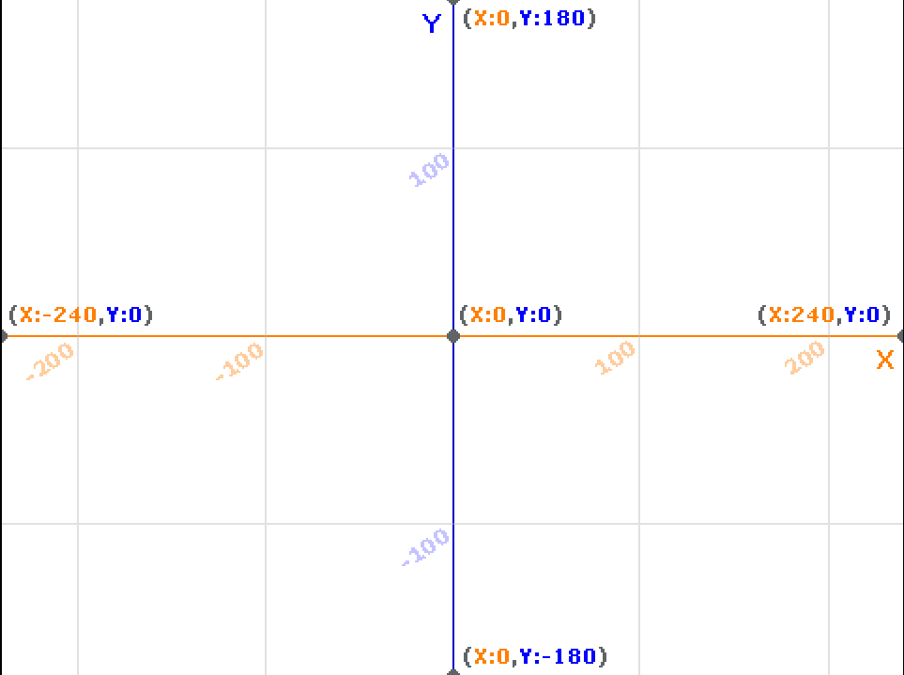
Final Rubric – For Mr. Bruno’s use ONLY
CATEGORY | 10 | 8 | 6 | 2 | 0
Complexity | Final image uses 10 or more lines. | Projects uses 8-9 lines | Project uses 6-7 lines. | Project uses fewer than 6 lines. | Project was not done.
Functionality | Project works perfectly as intended and has no bugs. | Projects works mostly as intended, but with a few bugs. | Project has several bugs that prevent it from working as intended. | Project barely works and has many bugs. | Project was not done.
Geometry | Scripts and coordinates are perfectly chosen to create geometrically accurate shape. | Scripts and coordinates are well chosen to create shape that is mostly geometrically accurate. | Scripts and coordinates are chosen to create shape that is somewhat geometrically accurate. | Scripts chosen result in shape that is geometrically inaccurate. | Project was not done.
Design | Project is well designed, without unnecessarily complicated scripts. | Project has a few unnecessarily complicated scripts. | Many of the project's scripts could be more simply designed. | Most of the project's scripts could be more simply designed. | Project was not done.
FINAL SCORE | /40

