Drawing with Coordinates 2 Worksheet Name:______________________________________________

- On the picture of the stage on the other side of this page, draw a picture. Your picture should:
  - Use only STRAIGHT LINES
  - Use AT LEAST 10 lines

- Then, draw a dot at the start and end of each line. Label each dot with its coordinates in parentheses (X,Y). (Write this directly on the picture on the back of this paper.)

- Use Scratch to write a script to have the sprite draw your picture using the or blocks. Draw your script in the space below. (Make sure that your script draws your picture correctly!)

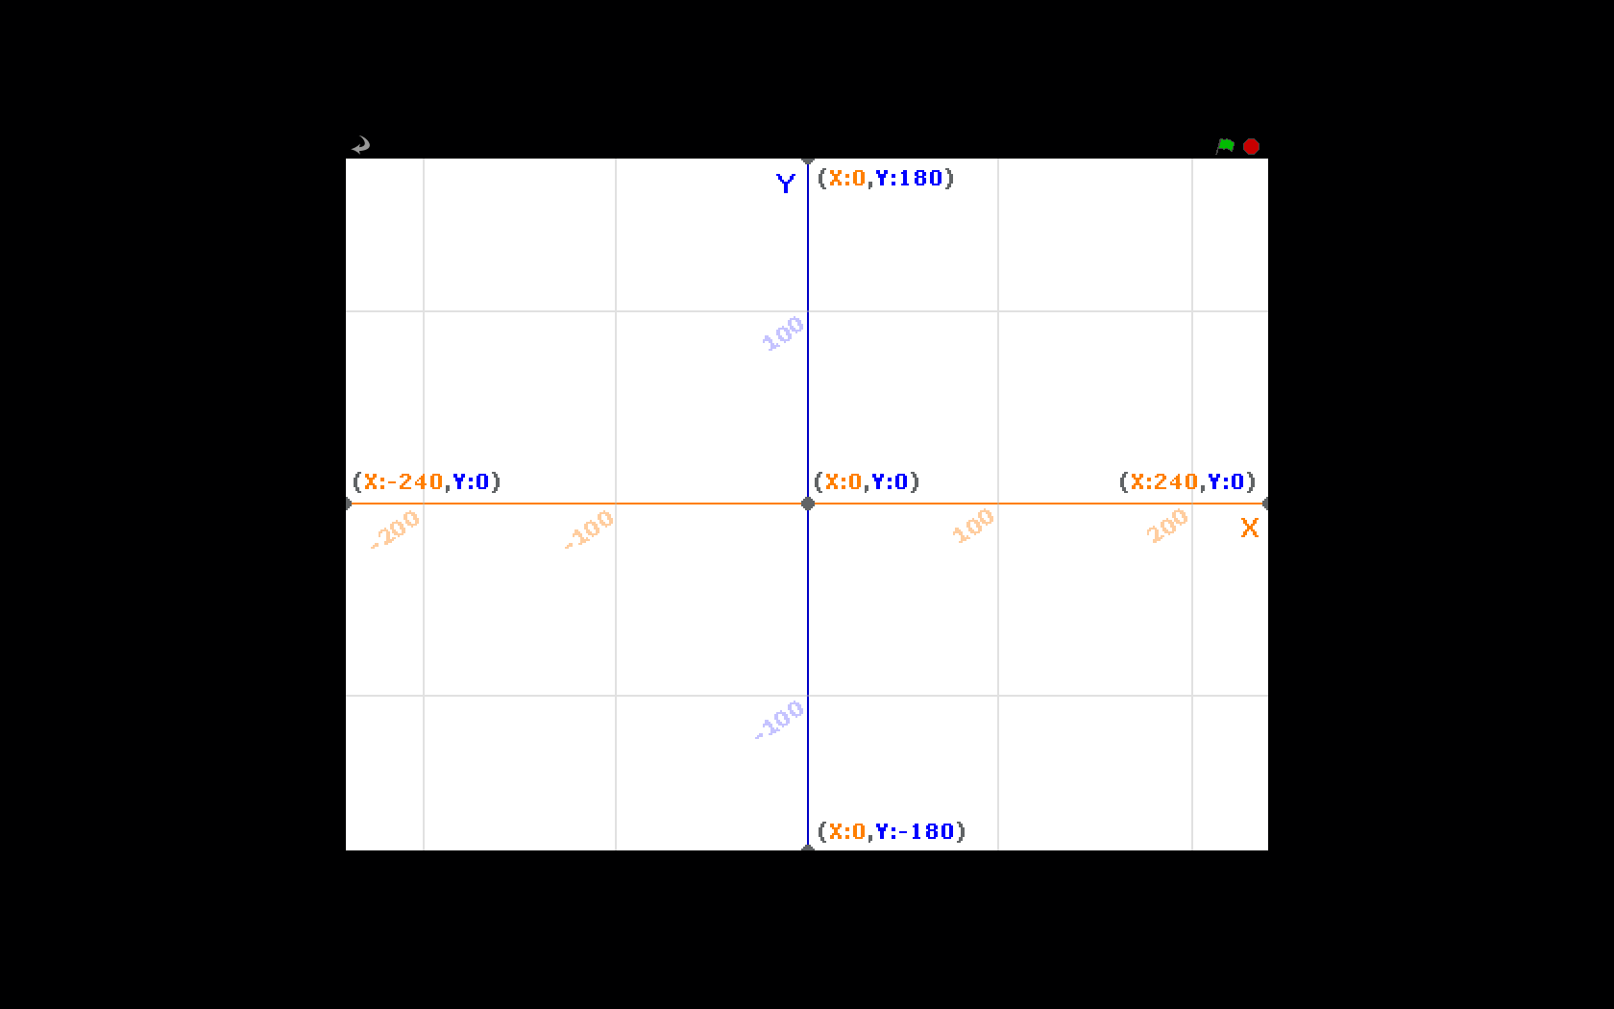

Exit Question: To get full credit on this assignment, make sure to COMPLETELY answer the Exit Question below.

