Coordinates in Scratch Worksheet Name:_______________________________

Answer the following questions using Scratch and the block or the block.
For each question, draw the picture on the stage write a script to draw the picture ACCURATELY, then draw your final script.

- Write a script to draw a smaller triangle inside of a large square.

Picture (label each point!) Script
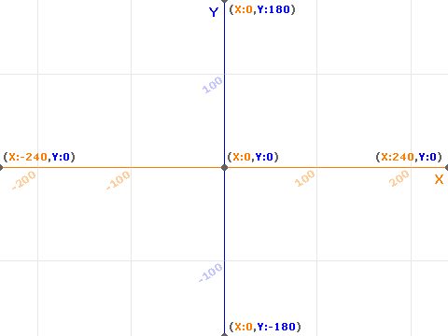

- Write a script to draw a simple house with a door.

Picture (label each point!) Script

- Write a script to draw a face with AT LEAST eyes and a mouth.

Picture (label each point!) Script

- Write a script to draw stick figure person.

Picture (label each point!) Script

- Write a script to draw a tree with many branches (it does NOT need to have leaves.)

Picture (label each point!) Script

