Playing with Tag Worksheet Name:_______________________________

Follow these directions CAREFULLY.

- Change the name of the cat sprite to “Cat”.
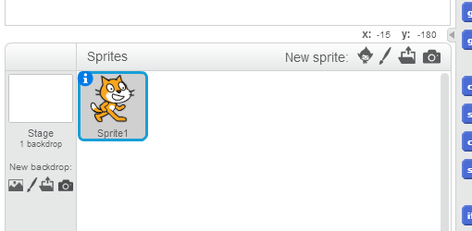
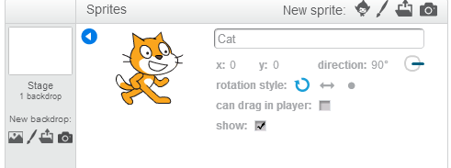
Click here!

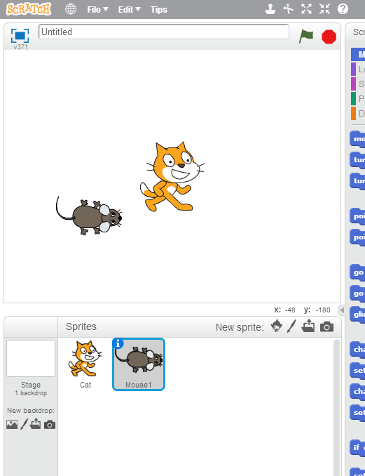
- Add a new sprite of a mouse. Click “choose sprite from library”, look in the “animals” section, and choose sprite “mouse1”.

Click here!

- Click on that sprite to change its name from “mouse1” to “Mouse”, just like you did for the cat in step 1.

- You can write different scripts for the Cat and Mouse sprites by clicking on their images below the stage. Write the following scripts CAREFULLY, and make sure each one goes with the correct sprite.

FOR THE CAT SPRITE: FOR THE MOUSE SPRITE:
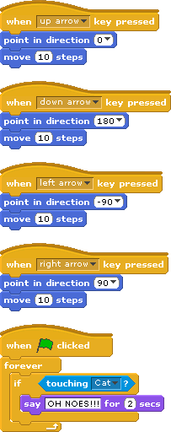
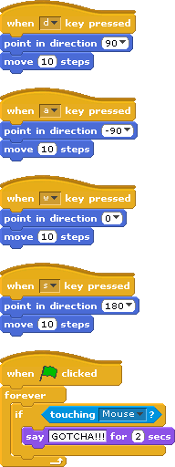

- Now click on the green flag above the stage, and use the keys on the keyboard to move the sprites around. (You may want to play with somebody sitting next to you, and you may want to shrink the sprites.) What happens when the sprites touch? Do you understand what each block does? Can you figure out how to make them say different things? What else can you change?

