Debugging 1 Worksheet Name:_______________________________
For each question, explain why the script does not work (where is the bug?) and draw a debugged script (one that works correctly).

- What is a “bug”?

- What is “debugging”?

- We want the sprite to draw a rectangle. Draw a circle around the bug(s), then explain and fix the problem.

Buggy Script Result Debugged Script
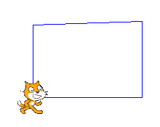
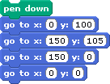

Explanation of bug(s):

- We want the sprite to draw a rectangle. Draw a circle around the bug(s), then explain and fix the problem.

Buggy Script Result Debugged Script
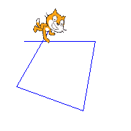
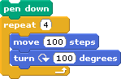

Explanation of bug(s):

- We want the sprite to draw a smaller square inside a larger square, but there’s an extra line! Draw a circle around the bug(s), then explain and fix the problem.

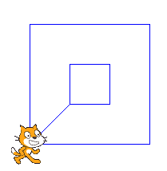
Buggy Script Result Debugged Script
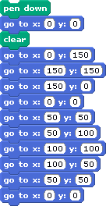

Explanation of bug(s):

- We want the sprite to draw a house with a door. Draw a circle around the bug(s), then explain and fix the problems.

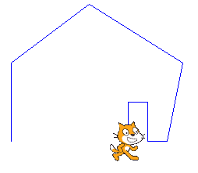
Buggy Script Result Debugged Script
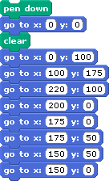

Explanation of bug(s):

