Notes: Debugging Name:_____________________________________

A _________ is a ______________________ in a computer program that makes it not work the way it is _______________________________.

If a computer program (or ________________) doesn’t work the way it is supposed to, that is almost always because of ________________________________.

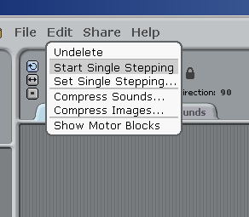
__________________________ is the process of ____________________ the bugs in a computer program so that it works the way it is supposed to.

If your script, or program, isn’t working the way you expect it to, a good debugging ____________________ can be to run the script in “__________________________________” mode. This will cause Scratch to run the script more slowly and __________________ each block as it is run. This can help you see which part of the script is causing the problem.

To start single stepping, go to the ______________ menu and select “Start Single Stepping”.

Notes: Debugging Name:_____________________________________

A _________ is a ______________________ in a computer program that makes it not work the way it is _______________________________.

If a computer program (or ________________) doesn’t work the way it is supposed to, that is almost always because of ________________________________.

__________________________ is the process of ____________________ the bugs in a computer program so that it works the way it is supposed to.

If your script, or program, isn’t working the way you expect it to, a good debugging ____________________ can be to run the script in “__________________________________” mode. This will cause Scratch to run the script more slowly and __________________ each block as it is run. This can help you see which part of the script is causing the problem.

To start single stepping, go to the ______________ menu and select “Start Single Stepping”.

