The If Block Worksheet Name:_______________________________

Answer the following questions using Scratch and the  block.

- What does the “if” block do?

- What is one way you can make the “if” block run forever?

- Use the block to make the sprite say “OUCH!” when you touch it with the mouse pointer. Draw your script below.

- Write scripts so that you can move the sprite around with the arrow keys. Then use the block to make the sprite say “OUCH!” when it walks into the edge of the stage. Draw your script below (you do not need to draw the scripts you use to move the sprite.)

- Underneath the stage, click on “Stage” and then click “Edit”. This will let you draw on the stage. Draw a red circle or rectangle on the stage.
Then click here!

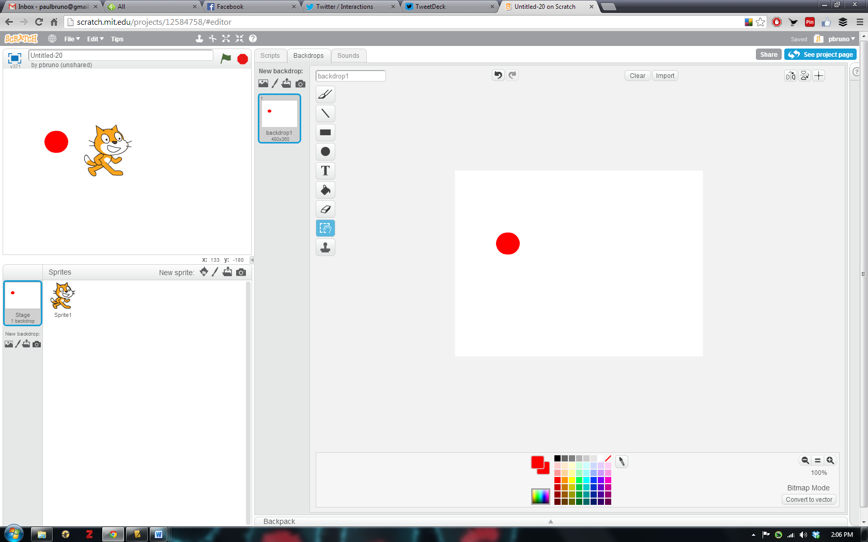
Click here first!

- Underneath the stage, click on “Sprite1” again. Now use the block so that when the sprite touches the shape you drew on the stage, it says, “OUCH!, Hot lava!”. (Hint: You can change the color in the “touching color” block by clicking on the color box and then clicking on the shape you drew.) Draw your script below.

- Make up one more thing to do with the “if” blocks. Draw your script below and explain what it does.

