The If Block 2 Worksheet Name:_______________________________

Earlier, you made a game of “tag” or “cat and mouse” using IF blocks. Today you will be modifying that game to include different rules.

- Make the game of “cat and mouse” or “tag” again. Remember, you need TWO sprites, and you need the following scripts for the sprites. (Make sure each sprite gets the correct scripts.) You can write different scripts for the Cat and Mouse sprites by clicking on their images below the stage. Write the following scripts CAREFULLY, and make sure each one goes with the correct sprite.

FOR THE CAT SPRITE: FOR THE MOUSE SPRITE:
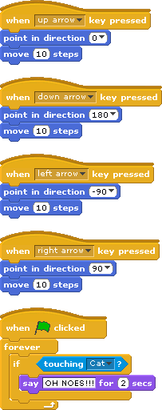
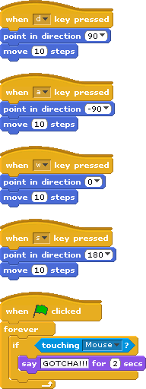

Make sure that the program works correctly. Now, save your work by clicking on “File”, then “Save As…”. You will have to name your project. (Remember the name you give it! I suggest “Cat and Mouse”.) Then click “OK”.

- Now you are going to change the program to make a better game. Change the scripts so that after the sprites “tag” each other, they go back to their “starting positions” so the game can start again! (Hint: you can use the block.) Draw the changes you made to the scripts below and save your program.

- Now draw a shape on the background and make it so that if the CAT touches the shape, the cat says something unhappy and the sprites go back to their “starting positions”. (Now the Cat can win by catching the mouse, or the mouse can win if the cat touches the obstacle. You may want to add more than one obstacle.) (Hint: you may want to use the block and make the color match the color of the shape you drew.) Draw the changes you made to the scripts below and save your program.

- Now make it so that if the MOUSE touches the edge, the mouse says something unhappy and the sprites go back to their “starting positions”. (Hint: you can use the block.) Draw the changes you made to the scripts below and save your program.

- Now, with the rest of class time, make up new rules to add to the game and briefly draw how you have to change the scripts to make those rules happen.
  - Rule 1 –

  - Rule 2 –

