Keeping Score with a Variable Worksheet Name:_______________________________

Earlier, you made a game of “tag” or “cat and mouse” using IF blocks. Today you will be modifying that game to keep score.

If you do not have a game of “cat and mouse” saved on your computer, you will need to make one and save it using the instructions on the back of this paper FIRST.

- Use a variable to keep score in your game. Follow the directions from the notes in class today if needed. The score should increase every time the cat catches the mouse. (If you are using different sprites, pick one to be the “cat” and one to be the “mouse”.)

- Now, come up with a new rule for your game so that IF something happens (you decide what), THEN the cat’s score goes DOWN by 1 point. Explain your rule below and then draw the changes you made to the script so that the cat’s score goes down when it happens. (Hint: you may want to use a block.)
  - What is your new rule? (“IF …… happens, then the cat loses a point.)

  - Draw your changes to the script below.

- Test out your game with another student to make sure the score keeping works correctly. If the score does not go up and down when it is supposed to, make sure to debug your scripts.
  - Does your scorekeeping work correctly?

  - If not, what bugs did your script have?

MAKING YOUR GAME

Make the game of “cat and mouse” or “tag” again. Remember, you need TWO sprites, and you need the following scripts for the sprites. (Make sure each sprite gets the correct scripts.) You can write different scripts for the Cat and Mouse sprites by clicking on their images below the stage. Write the following scripts CAREFULLY, and make sure each one goes with the correct sprite.

FOR THE CAT SPRITE: FOR THE MOUSE SPRITE:
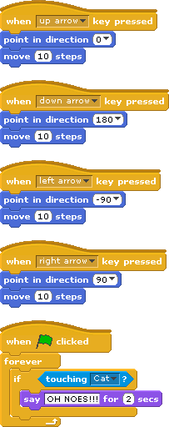
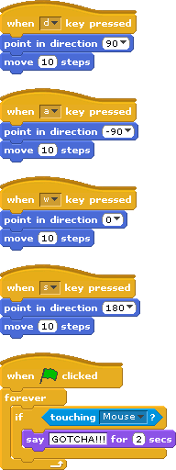

Make sure that the program works correctly. Now, save your work by clicking on “File”, then “Save As…”. You will have to name your project. (Remember the name you give it! I suggest “Cat and Mouse”.) Then click “OK”.

Exit Ticket Question:

