Debugging 2 Worksheet Name:____________________________________
For each question, explain why the script does not work (where is the bug?) and draw a debugged script (one that works correctly).

- We want the sprite to draw a triangle. Draw a circle around the bug(s), then explain and fix the problem.
Buggy Script Result Debugged Script
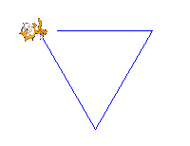
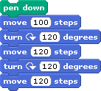
Explanation of bug(s):

- We want the sprite count up from 1 to 5, but it starts at 2! Draw a circle around the bug(s), then explain and fix the problem.
Buggy Script Result Debugged Script
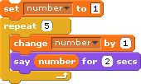
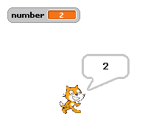

Explanation of bug(s):

- We want the sprite to walk in a square forever, but instead it walks in FOUR squares! Draw a circle around the bug(s), then explain and fix the problem.
We Want Buggy Script Result Debugged Script
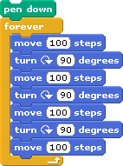
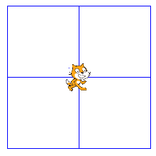
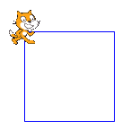

Explanation of bug(s):

- We want the sprite to say “OUCH!!” when it is touched by the mouse pointer. But if we press the green flag and then touch the sprite with the pointer, nothing happens! Draw a circle around the bug(s), then explain and fix the problems.

Buggy Script Result Debugged Script
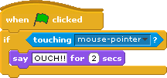

Explanation of bug(s):

- We want the sprite count up from 0 to 10, but it just says 0 and then says 1 over and over! Draw a circle around the bug(s), then explain and fix the problem.
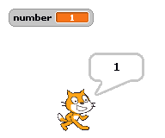
Buggy Script Result Debugged Script
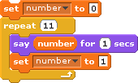

Explanation of bug(s):

- We want to play the cat and mouse game, but when you press the green flag the score goes way up and the sprites won’t move from their starting positions! Draw a circle around the bug(s), then explain and fix the problem.
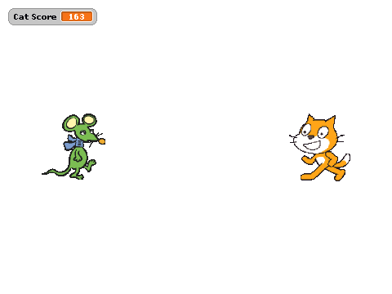
Buggy Script Result Debugged Script
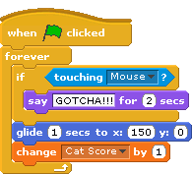

Explanation of bug(s):

