Scratch Crossword Puzzle Name:______________________________
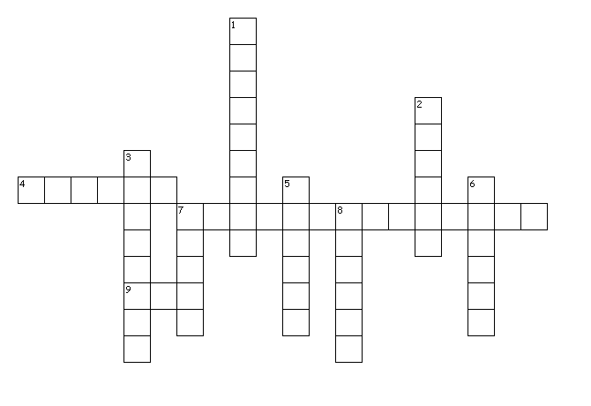
Across
4. This block makes Scratch run other blocks over and over again
7. This makes Scratch run scripts slowly, one block at a time, and highlights each block as it is run
9. A problem in a computer program that prevents it from working correctly

Down
1. The process of fixing bugs in a computer program
2. A set of instructions for a sprite to follow
3. Something that changes over time. In Scratch, you have to make them, then name them.
5. These are combined in different ways to create scripts
6. The language computers use that uses only 0's and 1's
7. The place on the screen where the sprites perform their scripts
8. A picture of a character or object that can be controlled using scripts

