Introducing the Helicopter Game Worksheet Name:_______________________________

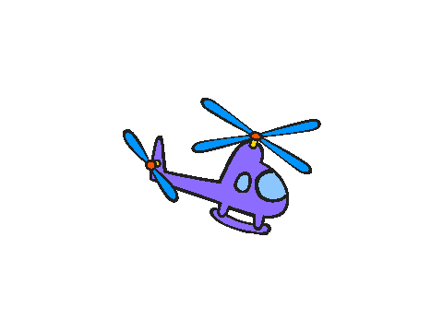
- Delete the cat sprite and add the helicopter sprite. You can find it in the “transportation” folder of sprites.


- Now, write a script that makes it so that if you press the UP arrow, the helicopter goes up, but if you DON’T press the up arrow, the helicopter goes down (like gravity!). Use these blocks:

Draw your script below, and save your work:

- Now, add to your script so that you can also move the helicopter to the right and to the left. There are different ways to do this, but you will probably need to add one or two more “if” blocks. Draw your new script below and save your work.

- Now, make a new variable to keep score in your game. (You should probably call it “score” or “points” or something like that.) What is the name of your variable?

- Now, add to your script so that if the helicopter touches the edge of the stage, you LOSE a point. You will probably need to use the block and another “if” block. Draw your CHANGES to the script below and save your work.

- CHALLENGE! Draw a small object on one part of the stage. Add to your script so that if the helicopter touches that object, your score goes UP by 1 point and the helicopter goes back to a “starting position” somewhere else on the stage. Draw the changes to your script below.

Exit Ticket Question:

