Using Costumes Worksheet Name:_______________________________

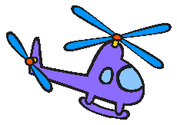
- Delete the cat sprite and add the helicopter sprite. You can find it in the “transportation” folder of sprites.

- Now, write a script that makes it so that if you press the UP arrow, the helicopter goes up, but if you DON’T press the up arrow, the helicopter goes down (like gravity!). You should also be able to move the helicopter left and right. Use these blocks:
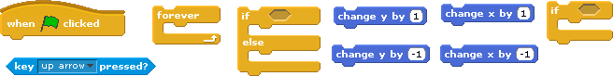

Draw your script below, and save your work:

- Now, draw a new costume for the sprite that looks like an explosion or fireball. (Remember, click on “costumes”, then “paint”.) Give this new costume a new name. What is the name of this costume?

- Now, add to your script so that if the helicopter touches the edge of the stage, the costume changes to the new explosion costume you drew. You will probably need to use these blocks: , , and . Draw your CHANGES to the script below and save your work.

- Now, make a new variable to keep score in your game. (You should probably call it “score” or “points” or something like that.) What is the name of your variable?

- Now, add to your script so that if the helicopter touches the edge of the stage, you LOSE a point. (So if the helicopter touches the edge, it looks like it explodes AND you lose a point.) Draw your CHANGES to the script below and save your work.

- Add to our scripts so that if the helicopter touches the edge of the stage, after it blows up and you lose a point, the helicopter goes back to the center of the screen and changes its costume back so it looks like a regular helicopter again. (It’s like the game is “starting over”.) Draw your CHANGES to the script below. You may save your work if you are pleased with your changes.

- If you finish with ALL of these tasks, find other ways to use costumes in Scratch. Describe one of those ways below.

Exit Ticket Question:

