Notes: Intro to Operators Name:_____________________________________

In Scratch, _____________________________ let you __________________________ other ideas together.

Many of these operators do things you have seen in __________________.

Some operators let you _____________________ values (like numbers).

Other operators let you _______________________ other blocks.

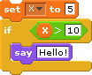
Examples:

Will the sprite say “Hello!” when you run this script? ____________
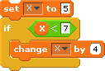

What will the variable “X” be after you run this script? ____________

Notes: Intro to Operators Name:_____________________________________

In Scratch, _____________________________ let you __________________________ other ideas together.

Many of these operators do things you have seen in __________________.

Some operators let you _____________________ values (like numbers).

Other operators let you _______________________ other blocks.

Examples:

Will the sprite say “Hello!” when you run this script? ____________

What will the variable “X” be after you run this script? ____________

