For each script, first PREDICT what the value of X will be when you run it, then TEST the script in Scratch.
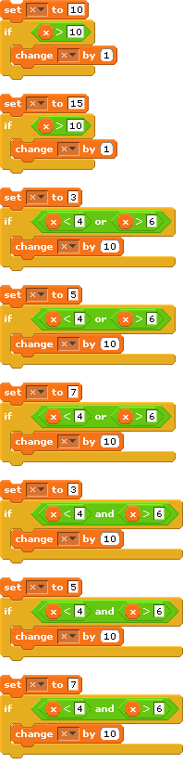
(prediction) x =
(test) x =
(prediction) x =
(test) x =
(prediction) x =
(test) x =
(prediction) x =
(test) x =
(prediction) x =
(test) x =
(prediction) x =
(test) x =
(prediction) x =
(test) x =
(prediction) x =
(test) x =

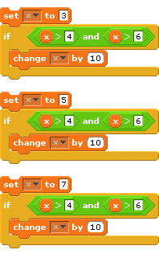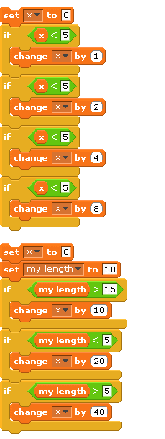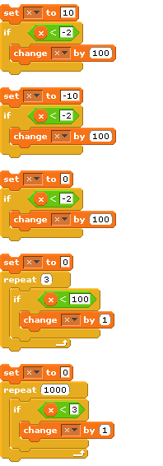
(prediction) x =
(test) x =
(prediction) x =
(test) x =
(prediction) x =
(test) x =
(prediction) x =
(test) x =
(prediction) x =
(test) x =
(prediction) x =
(test) x =
(prediction) x =
(test) x =
(prediction) x =
(test) x =
(prediction) x =
(test) x =
(prediction) x =
(test) x =
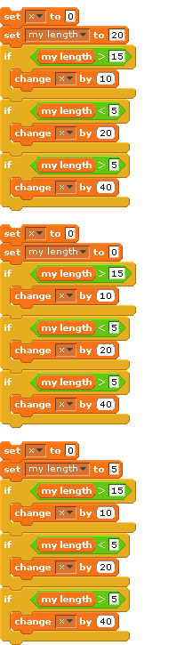
(prediction) x =
(test) x =
(prediction) x =
(test) x =
(prediction) x =
(test) x =

