Notes: Using Operators Name:_____________________________________

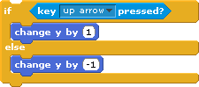
In our normal helicopter script, ________ the up arrow is pressed, the helicopter goes up, ____________ it goes down (because of “gravity”).

But what if the helicopter _______________ on something?

First, we need to make a ___________________. We’ll call it “_________________”. We also need another __________________ that looks like a landing pad.

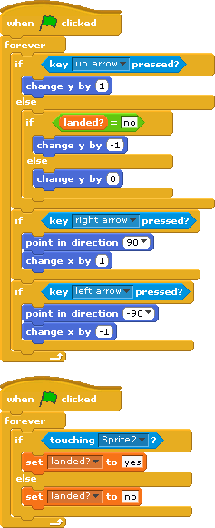
Now, IF the sprites are ______________________, “landed?” should be set to “_______”, ELSE, it should be set to “_______”.

Now, IF the up arrow is ______________ pressed and IF the sprites aren’t touching, we want the helicopter to get pulled down by gravity. That’s ____________ ifs!

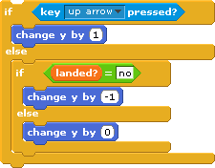
IF the up arrow is pressed, the helicopter goes ______.

IF the up arrow is _______ pressed, and the helicopter is _________ landed, the helicopter goes down. But if the helicopter is _________, it doesn’t go down!

