Pick Random Notes Name:____________________________________

The _______________________________ block is an ________________________.

Using this block will make the computer pick a random _______________________.
  - You can change the ________________ and ___________________ number possible.

Use the pick random block when you want something in your program to be ________________________. For example:
  - Where should a power-up _________________ on the stage?
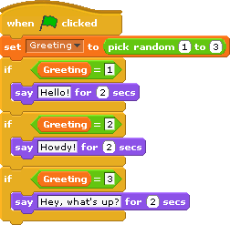
  - Make a character say something ____________________ each time you run a movie.

Pick Random Notes Name:____________________________________

The _______________________________ block is an ________________________.

Using this block will make the computer pick a random _______________________.
  - You can change the ________________ and ___________________ number possible.

Use the pick random block when you want something in your program to be ________________________. For example:
  - Where should a power-up _________________ on the stage?
  - Make a character say something ____________________ each time you run a movie.

