Rock Paper Scissor Worksheet Name:_______________________________

Get each part of this worksheet initialed by Mr. Bruno to get full credit.

Part 1 – Choosing Random Numbers Initials:____________

Before we get our cat and duck to pick rock, paper, or scissors we need to have both the characters pick a random number from 1 to 3, when the green flag is pressed.
Make the cat and duck pick DIFFERENT random numbers, and then say the numbers they picked.
Hints:
- You'll need to make 2 new variables: “cat choice” and “duck choice”
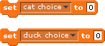
- If you want the cat and duck to say either 1, 2, or 3, what do you think you should set "cat choice" and "duck choice" to?
- How can you get your cat and duck to say their choices?
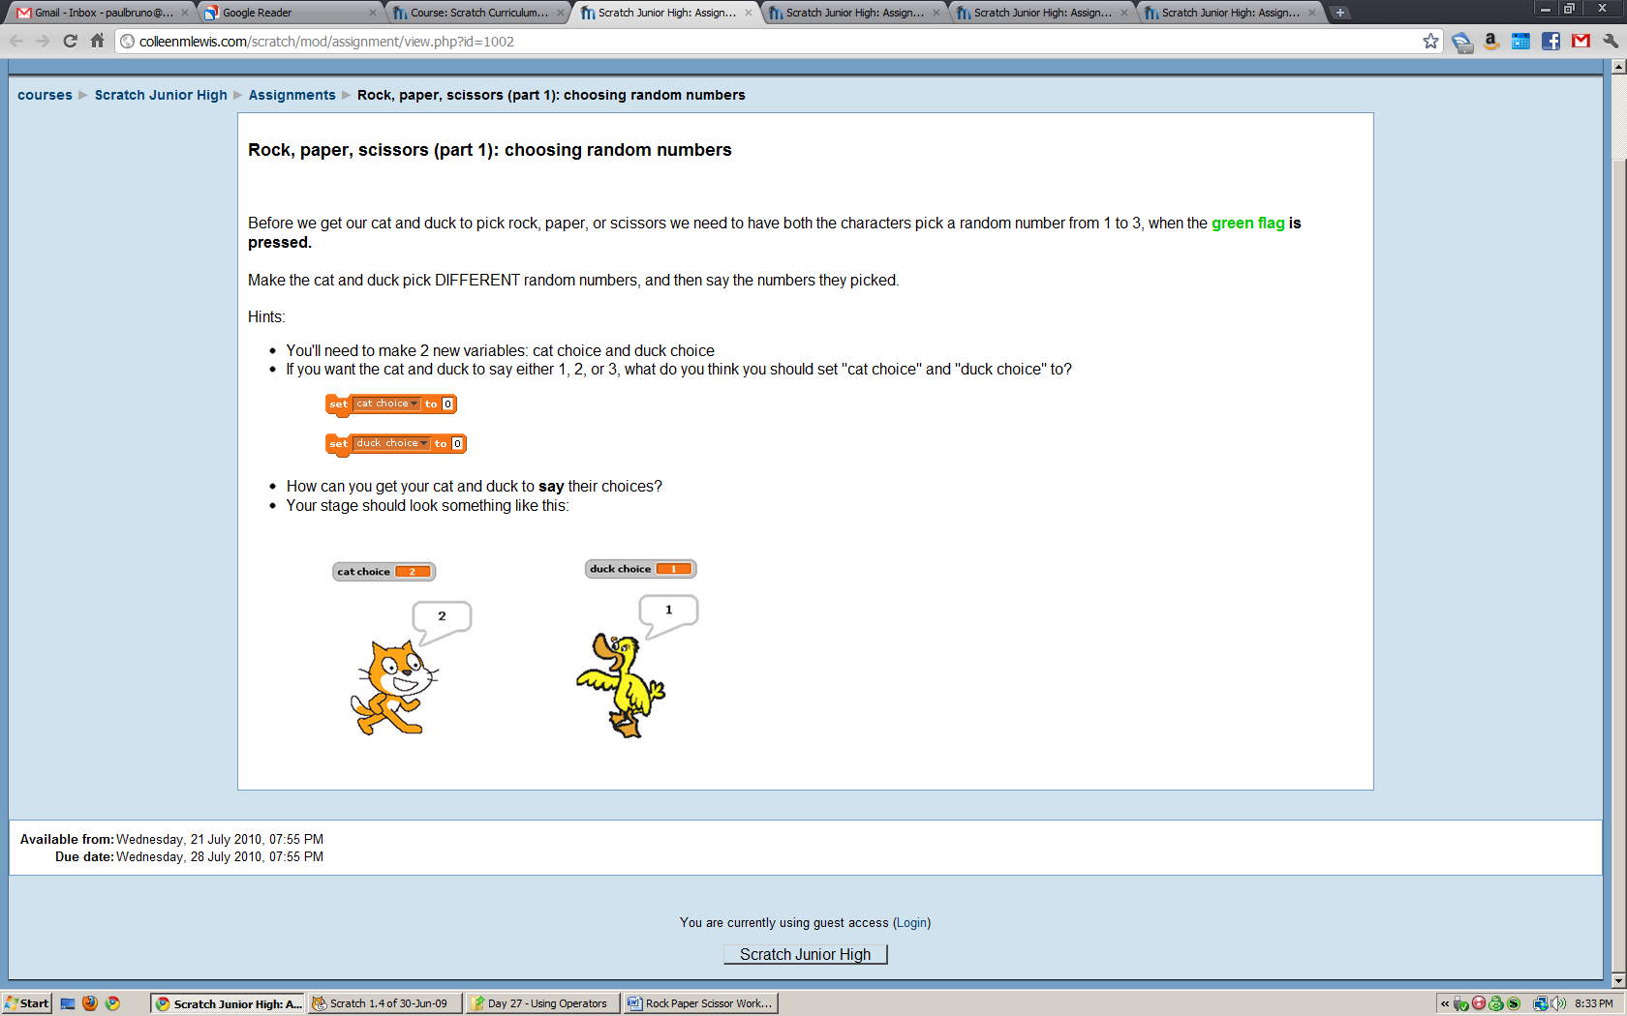
- Your stage should look something like this:

Part 2 – From random numbers to objects Initials:____________

Now that you have your sprites choosing random number and saying it we want to change it from saying the number to saying ROCK, PAPER, or SCISSORS.
- If the sprite randomly chooses 1, it should say ROCK!
- If the sprite randomly chooses 2, it should say PAPER!
- If the sprite randomly chooses 3, it should say SCISSORS!
Hints

- You will need to use "if" blocks.
- With the "if" blocks, you should use blocks that look like these:

- You should put a variable (cat choice or duck choice) inside the "equals" block (shown above).
- This is what your stage should look like:
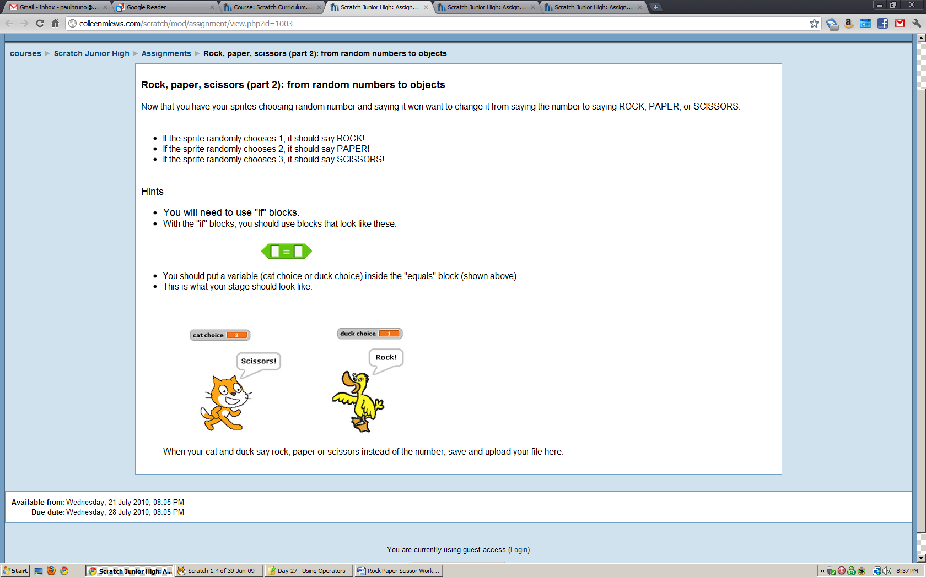

Part 3 – Add a referee Initials:____________

Now let's add a third sprite to play the referee! After the duck and the cat say their choices, the referee should say who won (or if there was a tie).

How can the referee tell who wins?

Hints:
- You will need to use if blocks, “equal” blocks, and “and” blocks. Maybe a lot of them.


- How do we get the referee to say who wins after the cat and duck say their choices? Hint: use the broadcast block.
- You should only be using 1 broadcast block, in the cat's code or the duck's code. Why can't you use a "broadcast referee" block in both the cat's and the duck's code?
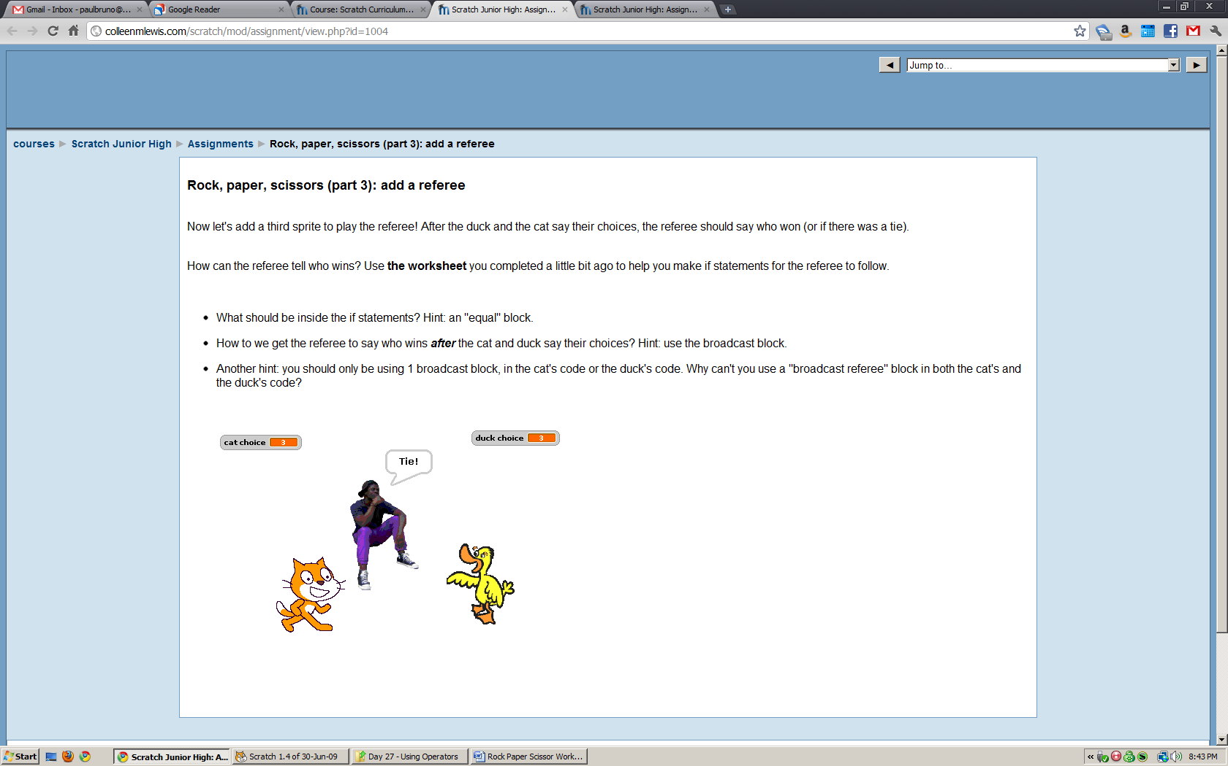
- Your stage should look something like this:

Part 4 – Keeping score Initials:____________

Now that you've got a referee, you need a way to keep score!
You will need to make 2 more variables "cat score" and "duck score."
- How should the variable "cat score" change when the cat wins?
- How should the variable "duck score" change when the duck wins?
- Does the score change when there is a tie?
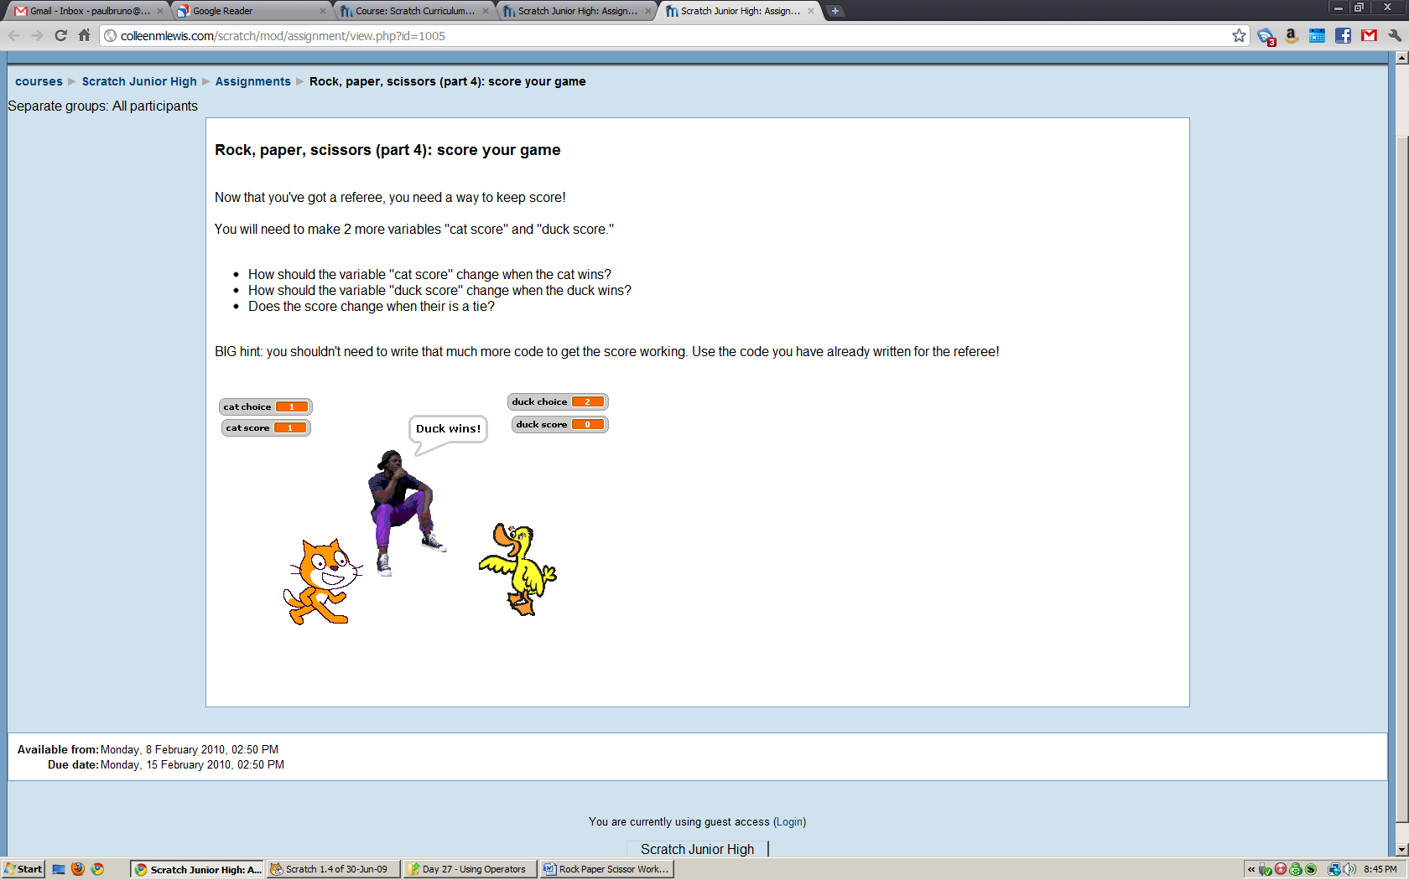
- You shouldn't need to write that much more code to get the score working. Use the code you have already written for the referee!

Your stage should look something like this:

