Random Number Game Worksheet Name:_______________________________

- Below is code to have the computer choose a random number and then have the player guess it. Although it isn't that cool yet! In the next few steps we're going to make it much more like playing the guess a number game with a person! First, make this in Scratch.
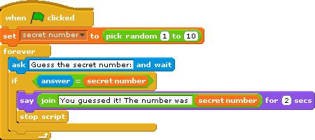

Each activity below will make the script more and more like a game between two humans. To get full credit, save your work online so Mr. Bruno can check it.

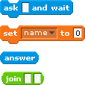
- The cat should welcome the player and ask for their name. After receiving the answer from the player, the cat should say "Hello [name]!"

Hints: You will need to make a new variable (“name”)
These blocks will come in handy:

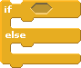

- If the player guess incorrectly, the cat should tell them "Sorry, that is not the right answer" before asking them to guess again.

Hints: You will probably need to use one of these blocks:
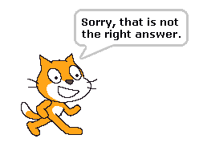

- If the player guesses incorrectly, the cat should tell them if the secret number is bigger or smaller than the number that they guessed.
Hints: You will need to use these blocks:
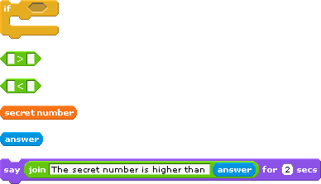

- Right now the cat always picks a number between 1 and 10. Change that to be between 1 and a variable named "maximum". Ask the player what they want to be the maximum number before choosing a random number. Use that maximum number as the highest number that the cat will chose. This way the player can decide how difficult they want the game to be.

Hints: You will need to make a new variable, “maximum”
You will need to use these blocks:
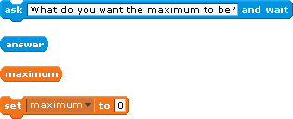

- Keep track of how many guesses it takes before the player guesses the right number.

Hints: You will need to make a new variable, “number of guesses” (or something similar)

Each time the player makes a guess you want to change the variable "number of guesses" by 1.
How can you do this?

- When the player guesses the secret number, tell the player how many guesses it took them and congratulate the player by using their name.

Hints: Remember your "number of guesses" variable? Now is time to use it! The cat should say
something like this "It took you ___ guesses to win!"
Remember you asked the player for their name in the beginning of the game? Now it is time to use it! You should have made a variable called "name" a few steps ago, but if you didn't go back and add this variable now. What should you set "name" to?
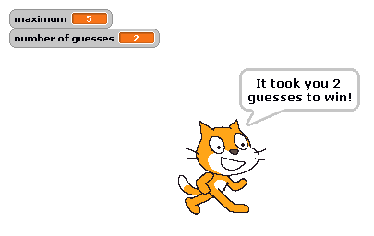
How do you join the word "CONGRATULATIONS" to the player name?

- For extra credit: What is the best strategy to use when guessing the random number? If the number could be anything from 1 to 100, is there a best number to guess first? What if that guess is too high? Too low? Describe the best strategy to use. Be clear and complete and use complete sentences. You may use another piece of paper if you want.

