Random Number Game Worksheet 2 Name:_______________________________

Below are more activities to add to your random number guessing game. Remember to have Mr. Bruno initial each one when you complete it.

- Keep track of how many guesses it takes before the player guesses the right number.

Hints: You will need to make a new variable, “number of guesses” (or something similar)

Each time the player makes a guess you want to change the variable "number of guesses" by 1.
How can you do this?

Mr. Bruno’s Initials_________

- When the player guesses the secret number, tell the player how many guesses it took them and congratulate the player by using their name.

Hints: Remember your "number of guesses" variable? Now is time to use it! The cat should say
something like this "It took you ___ guesses to win!"
Remember you asked the player for their name in the beginning of the game? Now it is time to use it! You should have made a variable called "name" a few steps ago, but if you didn't go back and add this variable now. What should you set "name" to?
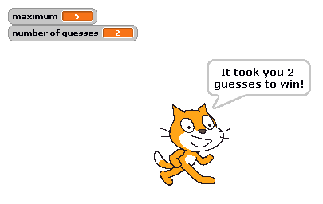
How do you join the word "CONGRATULATIONS" to the player name?
Mr. Bruno’s Initials_________

- For extra credit: What is the best strategy to use when guessing the random number? If the number could be anything from 1 to 100, is there a best number to guess first? What if that guess is too high? Too low? Describe the best strategy to use on the back of this paper. Be clear and complete and use complete sentences.

