Random Number Game Worksheet Name:_______________________________

- Below is code to have the computer choose a random number and then have the player guess it. Although it isn't that cool yet! In the next few steps we're going to make it much more like playing the guess a number game with a person! First, make this in Scratch.
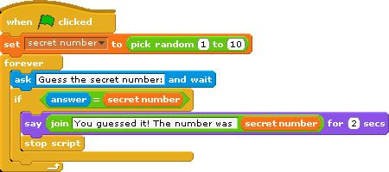

Each activity below will make the script more and more like a game between two humans. To get full credit, have Mr. Bruno initial each step as you complete them.

- The cat should welcome the player and ask for their name. After receiving the answer from the player, the cat should say "Hello [name]!"

Hints: You will need to make a new variable (“name”)
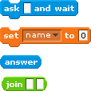
These blocks will come in handy:

Mr. Bruno’s Initials_________

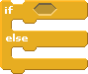

- If the player guess incorrectly, the cat should tell them "Sorry, that is not the right answer" before asking them to guess again.

Hints: You will probably need to use one of these blocks:

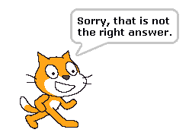

Mr. Bruno’s Initials_________

- If the player guesses incorrectly, the cat should tell them if the secret number is bigger or smaller than the number that they guessed.

Hints: You will need to use these blocks:

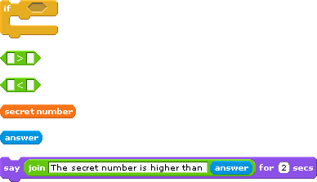
Mr. Bruno’s Initials_________

- Right now the cat always picks a number between 1 and 10. Change that to be between 1 and a variable named "maximum". Ask the player what they want to be the maximum number before choosing a random number. Use that maximum number as the highest number that the cat will chose. This way the player can decide how difficult they want the game to be.

Hints: You will need to make a new variable, “maximum”
You will need to use these blocks:
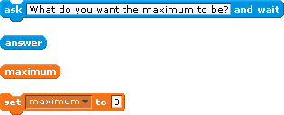
Mr. Bruno’s Initials_________

