- How many times does the note 62 play when you run the script below?
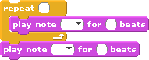
Answer:
- How many times does the note 64 play when you run the same script?

Answer:
- How many times does the note 52 play when you run the script below?
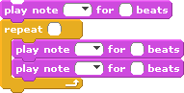

Answer:
- How many times does the note 62 play when you run the same script?

Answer:
- How many times does the note 52 play when you run the script below?
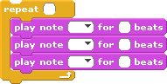
Answer:
- How many times does the note 62 play when you run the script below?
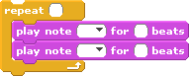

Answer:
- How many times does the note 64 play when you run the same script?

Answer:
- How many times does the note 62 play when you run the script below?
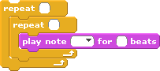

Answer:
- How many times does the note 60 play when you run the script below? 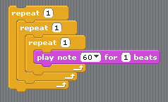
Answer:
- How many times does the note 60 play when you run the script below?
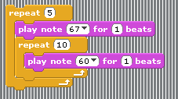
Answer:
- How many times does the note 67 play when you run the same script?
Answer:
- How many times does the note 60 play when you run the script below?
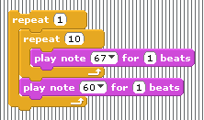
Answer:
- How many times does the note 67 play when you run the same script?
Answer:
- Write the order of the notes that would be played when you run the script below. 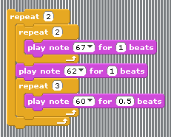
Answer:
- What is the value of tempo after we run the script below?
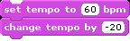
Answer:

- What is the value of tempo after we run the script below?
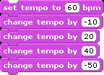

Answer:
- What is the value of tempo after we run the script below? 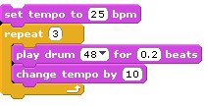
Answer:
- What is the value of tempo after we run the script below? 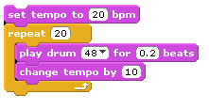
Answer:
- What is the value of tempo after we run the script below?
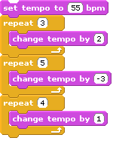
Answer:

