Example data-exploration plot for IST380, assignment 4, pr2

Overview: This is a scatter plot of the LendingClub interest rate (vertical axis) against the loan number (horizontal axis):

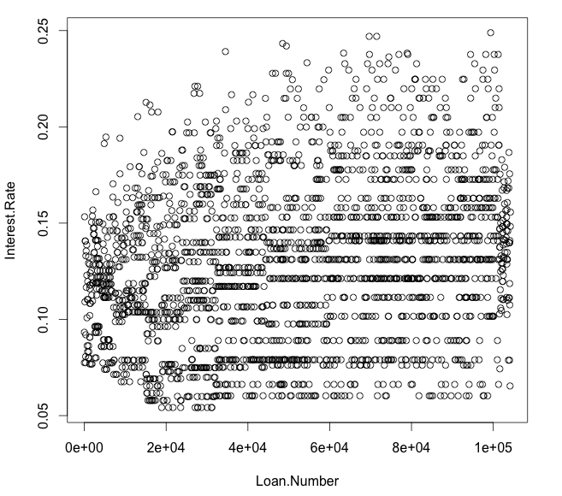

Conclusion: It seems that there might be a small relationship between loan number and interest rate. Certainly there must be other factors involved, but it might be interesting to see if the seeming rise in rate as the loan number increases is statistically significant… .

Code: Below is the R code that generated this:

ld <- read.csv("loansData.csv") # read in the data...

# attach the dataframe, ld
attach(ld)

# plot the interest rate vs. the loan number
plot( Loan.Number, Interest.Rate )

