AIBO

Intro
We decided to use the Sony AIBO because much of the desired basic abilities were already built in to the robot. Since we were starting on a new project mid-semester, it was ideal for us to choose a robot that would have some additional features to help us reach the goal by the end of the semester. Additionally, the Tekkotsu framework allows for customization of the robot’s behavior, thus making the AIBO an ideal robot to use. The main goal of our project was to have the AIBO follow a series of red lines, decide which direction to turn when reaching a fork, and find its pink ball. Initially, we were intending to have the aibo store information about the map and upon finding the pink ball, it will report back the shortest path from its starting position to the end. However, our software currently has the aibo following the red line and turning in certain directions depending on the type of corner/fork it encounters.

The AIBO has several sensors. When using Tekkotsu to test out its accuracy, we found that most of the sensors were unreliable. Instead, we decided to rely on the AIBO’s vision system. We were able use the Tekkotsu built-in calibration and raw camera system to easily segment input images into any desired colors. For our purposes, we wanted to detect the red tape that represented the possible path the AIBO could take. Our final goal was to have the AIBO follow the red line and turn when necessary.

Algorithms
Although we ended up not being able to implement and store a map into the AIBO’s system, we were able to have on hand Dijkstra’s shortest path algorithm written in C++. We coded this using many references we found on the internet and it is included in our source code. It was never used in our final algorithm.

Since we are attempting to find some goal but we do not know where the goal lies, we want to have the AIBO try to visit every vertex possible. We do not care for efficiency or shortest path. If we can have the aibo visit all possible vertices (or stopping points) on the map, then we will eventually find the goal. In this case, the goal is a blue cup.

Difficulties
One of the main difficulties we encountered for this project was the actual process of debugging and testing the AIBO. In order to test any code written, we first have to compile the code using Cygwin and upload it to the memory stick. Once the compilation is complete, we have to put the memory stick into the AIBO, boot the AIBO, and finally connect to the AIBO from the controlling computer. We then turn on the AIBO, and wirelessly connect with it through the main computer. Once that is done, we start up the GUI provided by the Tekkotsu framework. Every time there is an error or we must add more functionality, we must follow this entire process. In addition to the long debugging cycle, we spent quite a bit of time learning how to use the Tekkotsu framework. In fact, getting the platform up and running was a large part of the project.

Getting it working

Getting the AIBO to start and respond was a difficult milestone we had to overcome. It involved 4 steps:

1: Acquiring the Hardware
2: Installing the Software
3: Making it Work
4: Not Making it Fail

First we had to get the hardware – AIBO memory stick, wireless access point, and a Sony AIBO. Next, we installed Cygwin, Java3D, and Tekkotsu itself. Even after that, it took a while to get the AIBO to talk to the computer that we had to work with. And once all of that was done, there turned out to be some fairly problematic errors specific to the platform which we made. For a detailed report on how this is done, see “making_it_work.doc”. Although all of these issues were in some sense shallow, and did not involve any interesting problems in robotics, a large part of our time spent on this project went into getting past these issues.

State machine

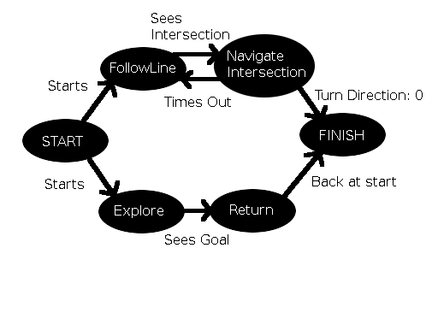
Figure 1: State machine that we used to get from the start, to the goal, and back to the start.

Tekkotsu supports the construction of complex state machines using behaviors as building blocks. We took advantage of this fact: we wanted the AIBO to exhibit fairly complex behavior, and controlling all of that with some sort of control scheme within a single behavior, or perhaps by using global variables, would have been unclear and overcomplicated. Because Tekkotsu makes the implementation of state machines so (relatively) simple, the construction didn't actually take that long.

Our state machine involved two pathways (it could properly be considered two state machines running at once) as seen in Figure 1. The lower layer was a local control layer. It had two states (each state is also a Behavior): FollowLine and NavigateIntersection. The FollowLine state does visual processing to find a red line in the visual field, and then issues a motion command to re-center that line. At the same time, it checks the images that it processes to see whether they contain an intersection. If they do, it sends a completion signal, which causes the state machine to fire a completion transition, and activates the NavigateIntersection state. The NavigateIntersection state moves forward for a set time period (at a set target velocity) and then either continues forward, or executes a turn to the left or right. A timer is placed on the NavigateIntersection behavior, after which it transitions back into the FollowLine behavior. A global variable determines which way the NavigateIntersection behavious turns. Together, the NavigateIntersection and FollowLine behaviors form the lower layer of the state machine, and they function to guide the AIBO along the lines of the graph. By themselves they are sufficient for unplanned motion along the graph.

The upper layer of the state machine also contained two states: the Explore state and the Return state. These states had access to what type of intersection the AIBO was viewing at the moment (based on a decision made from visual input to the FollowLine behavior) and if our project had been completed, would have shared a global map. Their job was simply to modify the global variable that indicated to NavigateIntersection which direction to turn in so that the lower layer of the state machine would move on the graph according to the plan. Explore was to implement a graph exploration algorithm, although neither Explore nor Return was ever put together and tested. Explore would make turn decisions based on the known graph topology that would cause the AIBO to explore the graph in an efficient manner. It also did visual processing that searched frames for blue pixels, and if enough were found, transitioned into the Return state, the goal having been found. This much functionality was tested, and the parallel visual processing in FollowLine and Explore was a success. The Return behavior was tasked with returning the AIBO to its known start position given its location in the graph after finding the goal. Again, all that it did was issue turn decisions based on intersection types. However, together, the Explore and Return behaviors provided high-level motion planning for the AIBO. When combined with the lower layer of behaviors, the entire state machine executed the goal in mind: navigate a known graph to find a goal, and then return efficiently to the starting position.

The state machine contained two additional states: the first, the start state, simply did nothing, except to immediately signal completion so that transitions into both the FollowLine and Explore state could be accomplished at once. Also, if setup or starting behavior was later needed, it would have been inserted here. The state machine also contained a final state. If the Return behavior determined that the AIBO was back at the starting location, it would write 0 into the global variable that determined turn direction and turn itself off. When NavigateIntersection found the 0, it would immediately signal completion, which caused a transition into the final state. This state did nothing, although some sort of victory dance or transition to other behavior could have been added.

The two-layer, 6-state state machine for our purpose was easy to construct using Tekkotsu, and had we had the time to fully implement and test it, would have proven a robust system for control. By separating high-level motion planning from low-level path-following behavior, we not only simplified our code, but made it more powerful: during our demonstration, even though the high-level motion planning was not working, the AIBO managed to follow a line in the graph. The construction is also somewhat modular, allowing a behavior like FollowLine or NavigateIntersection to be used in another project without much modification. The ease with which such complex behaviors can be constructed is one of the strong points of Tekkotsu, and although never fully integrated, our system managed to perform fairly well due to the modularity of the state-machine paradigm.

For more information on Tekkotsu state machines please see the following link:

http://www.cs.cmu.edu/~dst/Tekkotsu/Tutorial/state.shtml

Navigating the map with vision

Our path following algorithm used the center of the road to stay on track. It was easy to calculate the center on a strait path, as seen in Figure AA(a). In this case we took the average of all red pixels. However, it was not as simple when we hit a fork, like in Figure AA(d). If we tried to use this same algorithm to calculate the center then our center would have been off to the left, causing our AIBO to stray off path.

To find the centers of forks and paths we came up with a more complicated algorithm. This algorithm used the pixels of a straight path to find the x-value of the center of the path and used the pixels of a forked path to find the y-value of the center of the path. To do this we scanned every row and, while summing its x and y-values, counted the number of red pixels in the row. If the row had more red pixels than a preset threshold th_linewidth, then we labeled it as a row of a fork and used its y-sum to find the y-value of the center of the path. If the number of red pixels was less than the threshold th_linewidth, then we labeled it as a row of a strait path and used its x-sum to calculate the x value of the center of path. The algorithm can be seen in action in figure AA.

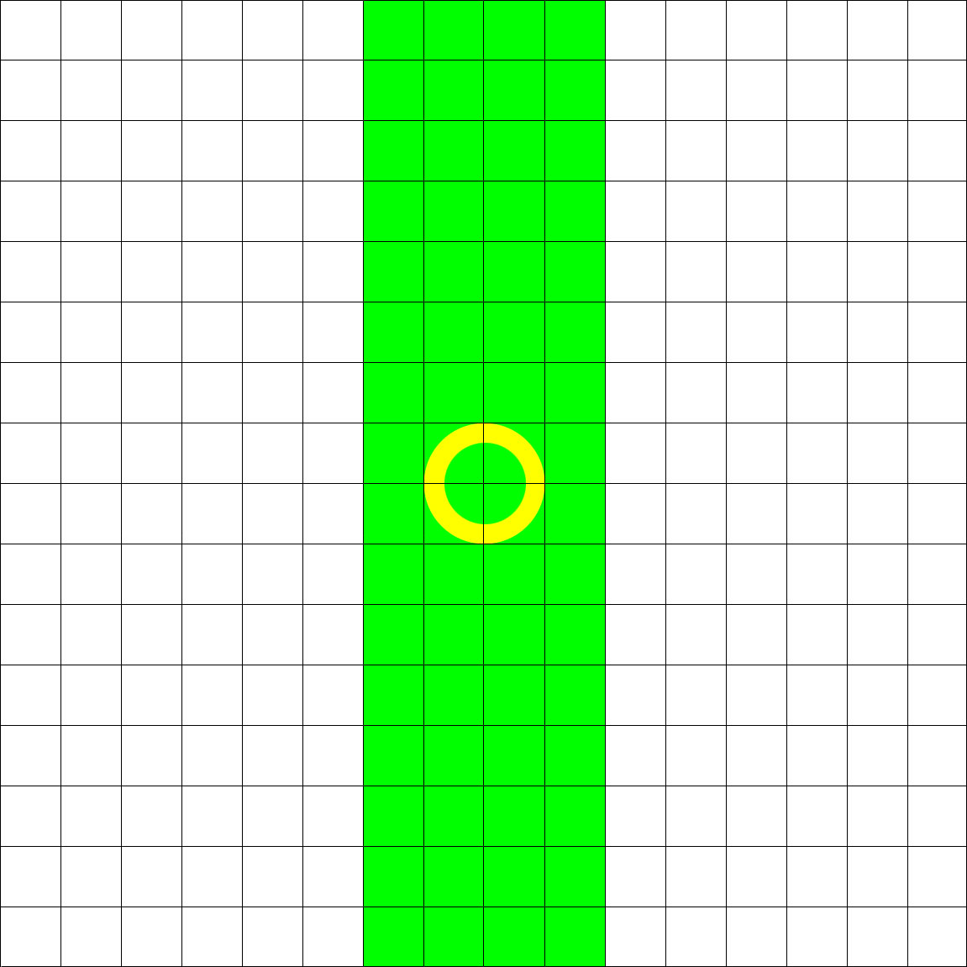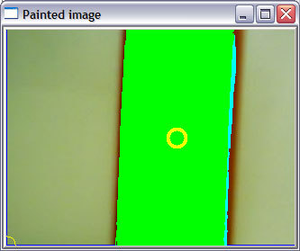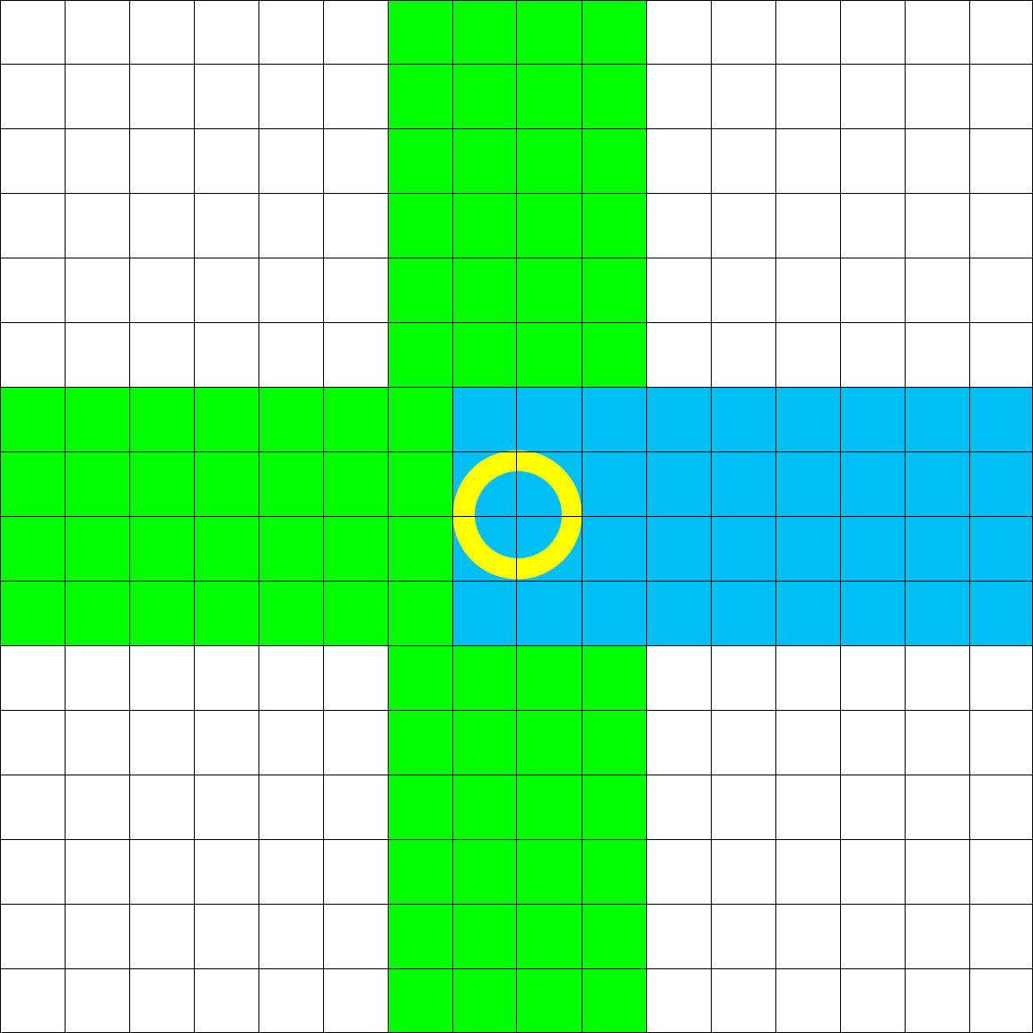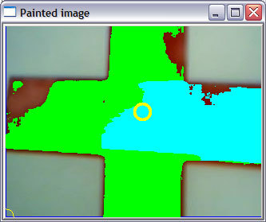
(a) (b)

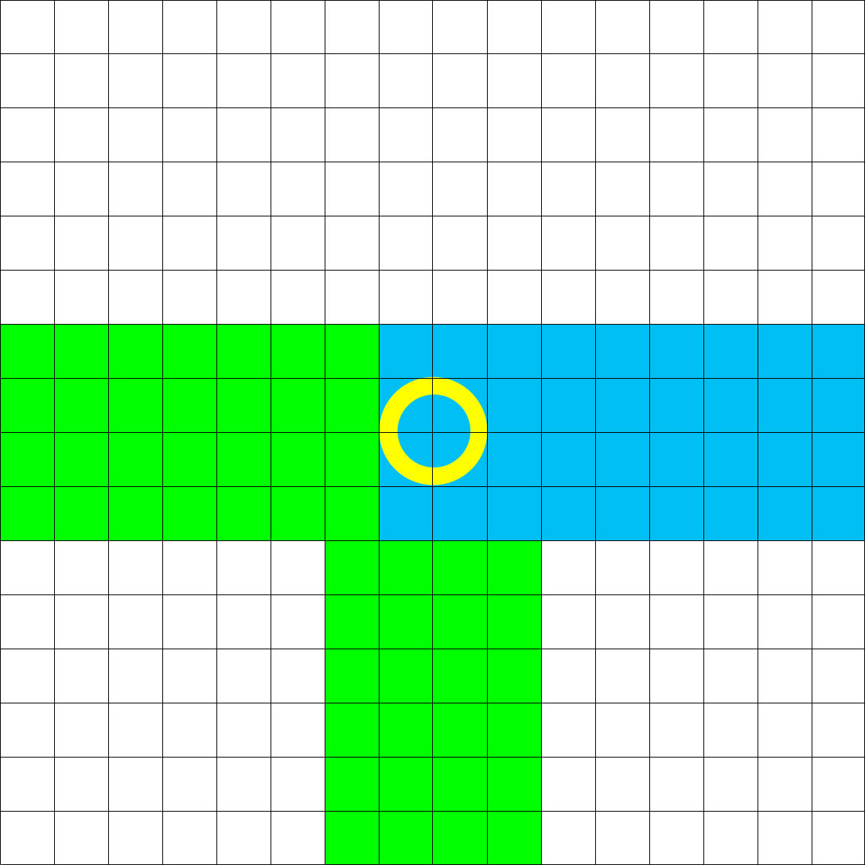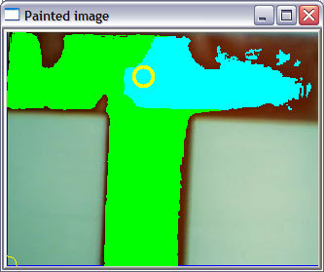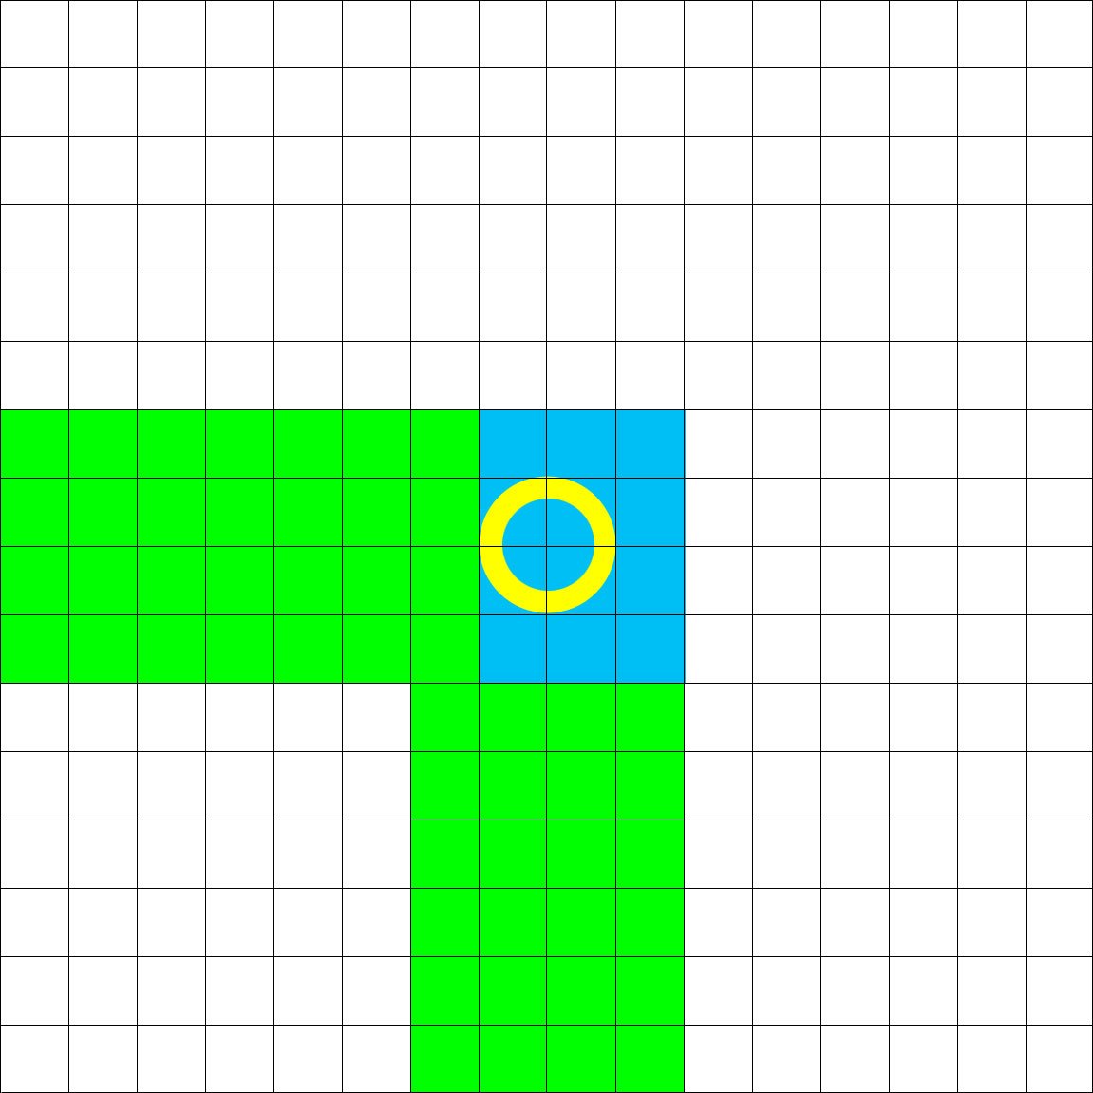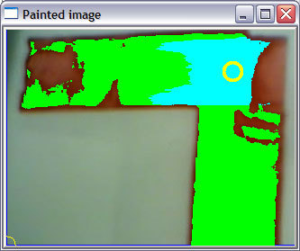
(c) (d)
Figure AA: Shows how our algorithm works theoretically and how it performed in real life. Notice how after every seventh green pixel in each row the pixels are highlighted blue. These rows were used to calculate the average y-value for the center. The other rows were used to calculate the average x-value for the center. The images show how our program worked on (a) a straight path, (b) a cross-shaped path, (c) a T-shaped path, and (d) a L-shaped path.

Figure AA shows 1) how our program works theoretically and 2) how our program actually performed. In the theoretic version the threshold is set to 7, so any row with less than 7 red pixels (that are highlighted green) are considered as a row of a fork. Pixels in rows that pass this threshold are highlighted in a different color (light blue) so show that the row has passed the threshold. As one can see in Figure AA, the algorithm worked well.

Another problem was detecting when we hit a fork. It was necessary to know when we hit a fork to keep track of where we are on the map. If we were unable to turn correctly, we would lose track of where we are. We detected forks by counting the number of rows that had passed the threshold th_linewidtd. If this was bigger than another threshold th_forkwidth, then we have reached a fork. To maneuver around the fork we used another algorithm to determine what type of fork it was.

To determine what type of fork we have reached we scanned four sides that made up a box around our fork center. If there number of red pixels on a side was greater than the threshold th_forkwidth, then we said that the fork had a path that went in that direction. Figure BB illustrates how our algorithm works.

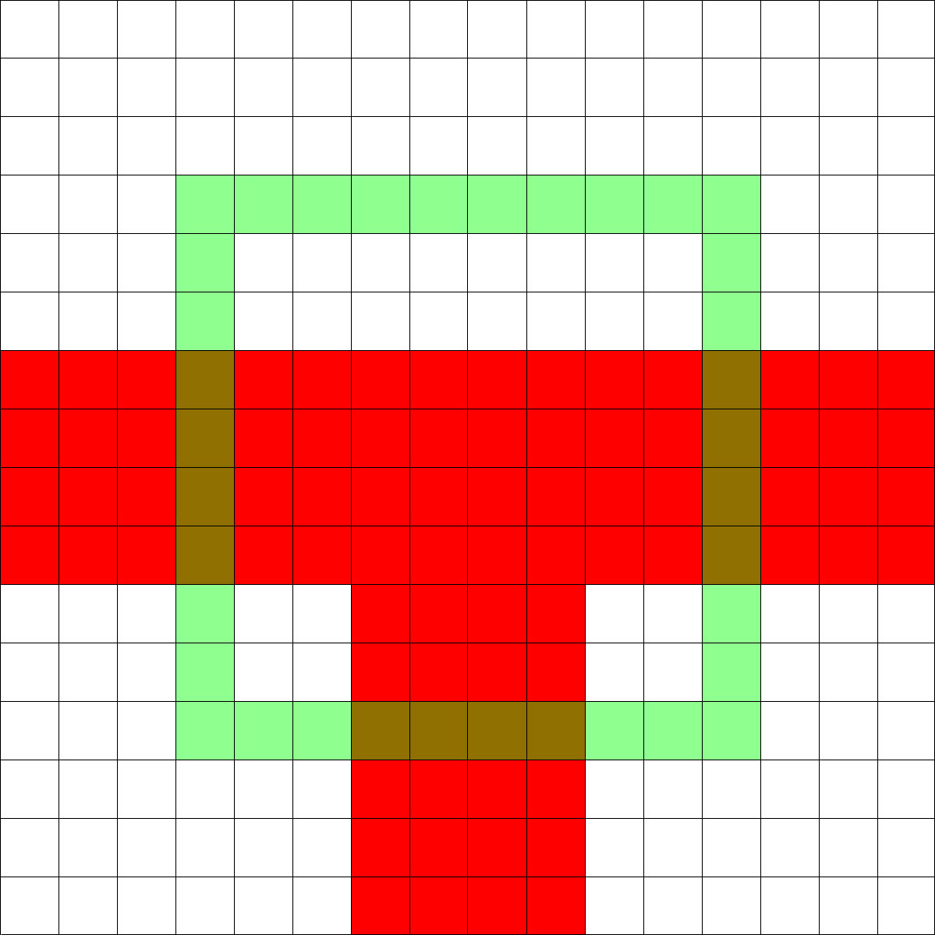
Figure BB: This shows how our fork identifier algorithm works. The red is the path and the green overlay is the range where we are looking for a path. Since the overlay crosses 4 pixels on the right, bottom, and left side, our algorithm will identify the fork to have these paths. So it will label it as a T-shaped fork.

In Figure BB, th_forkwidth is set to 3 so the fork had paths that go to left, down and right. It then used this information to determine that it is a T-shaped fork.

Now that we can navigate through paths we need to know when we have reached our goal, the AIBO’s pink ball. To detect the goal we scanned every pixel from left to right and from top to bottom counting the pixels that were pink. If the number of pink pixels was greater than the threshold th_goalNum, then we said that our goal was in sight and in range.

Conclusion

Although we did not have time to integrate Dijkstra’s algorithm into the system, we were able to have the aibo follow any type of red line or blob that it finds in its vision system. The state transitions for the Explore and Return states worked as well, but the Return state functionality could not be added in time.

If we were to start over, one thing that we would change is the debugging and testing process. Instead of having just one main computer, it would be more efficient to have some sort of source control for our code and allow for all team members to program on their own computers. This would take some additional time since it would require setting up cygwin and Tekkotsu on these different computers. This also means that the team will have more than one memory card devoted to programming the AIBO.

For future work, we would integrate the shortest path finding algorithm and have the aibo walk from its goal back to the start using the information found.

Included files: included are “making_it_work.doc”, a detailed explanation of the obstacles overcome in getting this project to the stage that it is at. Also, “AIBO_project.zip” includes all of the source code for our project. Files are in the correct directories relative to the project root directory, although the contents of those directories which we haven’t touched have been omitted from the archive.

