Writeup for the Field/Smith Evolution ER1 Robotics Project
Adam Field
Stephen Smith

Our project's primary goal is an autonomous robot which moves around an area, searches for sheets of paper with textual information on them ("documents"), and takes pictures which will contain the document. A secondary goal will be to cause it to take the pictures such that they will contain the entirety of the paper, and for the picture to be readily segmented by Laserfiche's PhotoDocs software.

Implementation

Our project was divided into three pieces: getting sensory data from two webcams, processing that data to move the robot appropriately, and taking high resolution pictures of located documents. These three processes were entirely distinct (in fact, they were all implemented in different programming languages), and communicated with each other as little as possible.
Sensory subsystem
(main file: cs154v1.vcproj)

The first piece we worked on was camera i/o (written in c++, using OpenCV). After all, in order to find documents, you first need to be able to recognize them. Our first thought was to use Haar Wavelets, as this is the generally accepted way of determining whether a certain object, such as a document, is present in an image. We decided against this for two reasons: we realized that it would take a fair amount of time to figure out how to actually use this approach – time we didn't have due to technical complications – and, more importantly, our camera couldn't support that sort of approach. Ideally, we would like to differentiate between a piece of paper with text and a blank piece of paper, but with the sensors we had available papers looked something like this (this piece of paper had a single large 'F' written on it):

Clearly, any approach that relied on the presence of text simply wouldn't work. So, we simplified our goal significantly, based on our time and resolution limitations. Our goal would be to find white, reasonably rectangular objects – the same square-finding algorithm our Clinic project uses. There was one major difference between what we had to do here and what we had to do in Clinic: Clinic pictures were assumed to be of high quality, whereas those from our sensors were very much the opposite. So, we needed to preprocess them a great deal more. We tried a handful of approaches, but the simplest turned out to be the best. We took the saturation and value of each pixel, set that pixel's blue channel to (value)⁶ * (1 - saturation)⁵, and zeroed the other two channels. This removed virtually much all the noise in the image (that is, anything that wasn't pure white), allowing us to run the Canny edge-finding, contour-finding and polygonal simplification algorithms used in Clinic. We relaxed some of the constraints to account for the much lower-resolution images we were working with; the quadrilateral restriction stayed. At that point, we obtained a picture that looked more like this (with the possible edges highlighted in green):
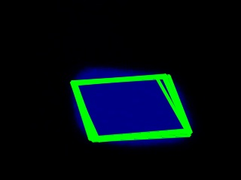
Other white objects also show up after preproces
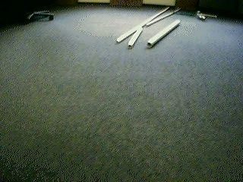→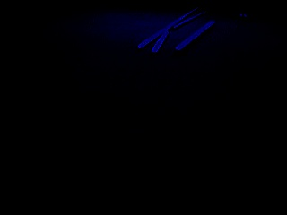 sing, but most of them aren't very rectangular. For instance:
Occasionally, we'd see something that wasn't paper get caught by our system (notably: the top of a particularly reflective computer case), but that is to be expected given such a simplistic technique and such little data.
Once we find a set of possible documents, we then find the quadrilateral with the largest area, determine its center, and save that point to a file. If no quadrilaterals were found in the image, we simply blank the file, indicating that no sensory data is available.
One more word about the vision aspect: we started out only using one camera, pointed towards the ground at about an 80 degree angle. This is obviously the angle we want to use in centering the robot on a document found on the floor, but it makes it difficult to locate a piece of paper without stumbling upon it by accident. So we added a second camera, of the same quality as the first and running the same paper-finding code, but at a higher angle and printing its output to a different file. This created some minor complications, as OpenCV makes it difficult to use multiple cameras concurrently, but eventually we found a solution (albeit one that requires more human intervention when setting up the robot), and called the sensory piece done.
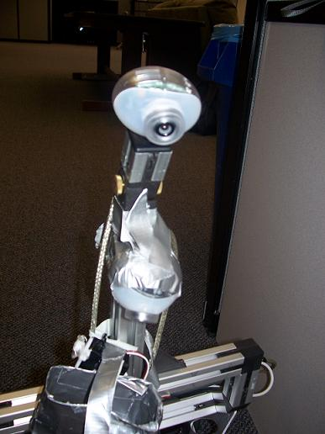
Our two eyes, mounted to the robot. The top one is attached in the usual way; the bottom one is held roughly in place with lots of duct tape.

Motion subsystem (main file: main.py)

Once we have information about where documents were, we must figure out what to do with the information. This piece was written entirely in Python, as that was the language our ER1 API was written in. Thus, after importing the provided ER1 motion code, we first directed our robot to center itself on the point written to disk by the bottom camera, if there was such a point. If not, then it would try to move towards the point found by the wider-angle camera, until such time as that document is picked up on the lower camera. If neither camera found anything, then it would wander randomly until that changed.
Complete random motion isn't terribly effective, so we modified that motion in a two ways. First, we allow the motion to build up a bit of momentum - that is, we bias its rotational and translational movement slightly toward their previous value. Secondly, sometimes it goes into wander mode after having found a document, and then momentarily lost it. Thus, we also bias its motion towards the last direction it was intentionally moving. If it loses the document and then fails to find it again, we allow this effect to fall off after a few cycles.

Photography subsystem (main file: arduinotester.pde)

Once the bottom camera has found a document and centered on it, we need a way for the robot to collect the picture. Our sensory cameras are entirely useless for this purpose – we need a picture that we could have OCR run on it to capture the text inside the document, but those cameras are unable to see any text. Thus, we created a holder for an actual digital camera and attached a controllable digit to press the camera's button:
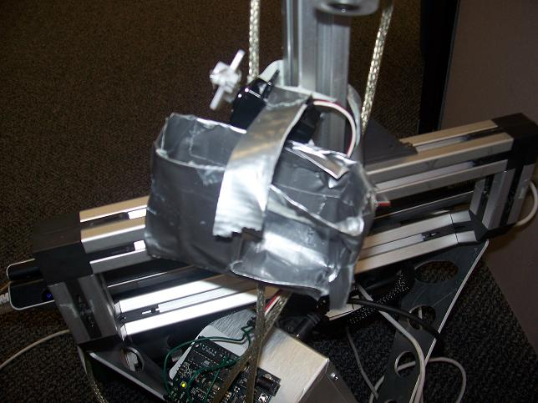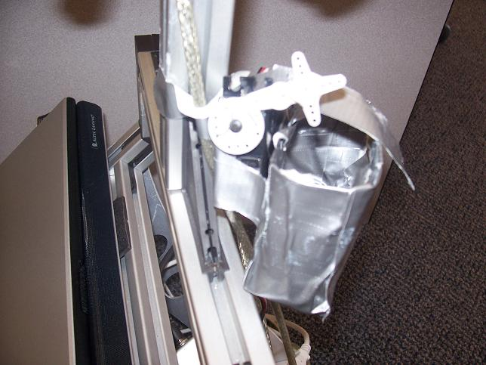
On the left, the front of our robot; the case is hanging loose, as the camera it was designed for was being used to take this picture. On the right, a side-view of the plastic digit.

The digit itself was just made of plastic and wire, attached to a servo motor. The servo, in turn, was wired to an Arduino board taped to the robot's battery:
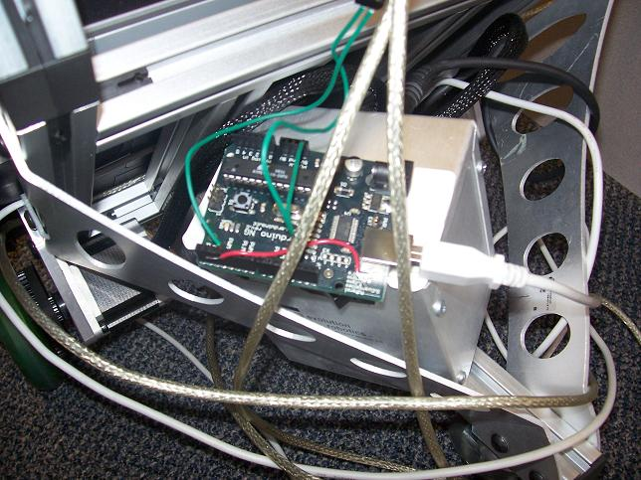
The Arduino is an I/O board that can be flash-programmed in its own language (though that language is almost identical to C, so much so that the Arduino IDE saves a copy of code as a .cpp file before compiling). Programming it was straightforward once we knew where to look. It accepts input from USB, and can output analog signals to devices (such as servos) attached to it. Thus, we programmed the board, using the freely-available Arduino IDE, to sit and wait for a signal from the motion system. Once it centers itself on a document, the robot sends such a signal and pauses for several seconds. In this time, the Arduino tells the servo to rotate, depressing the camera's button and capturing a digital photo of the document. 2 seconds later, it sends another signal telling the servo to resume its default state; the robot then makes a full 180 degree turn, and starts the process again from the beginning.

This all worked in theory; by itself, the digit would succesfully activate the camera 100% of the time. However, once everything was attached to the moving robot, the pieces started to misalign; by the time the robot signalled for a picture to be taken, the digit was no longer in the correct position and couldn't depress the button enough to activate the camera. We are forced to admit that while duct tape is amazing at sticking two large objects together and constructing nunchaku, it is much less effective at forcing objects to remain in the same relative position while both are being jostled. Fundamentally, our system worked, but would have required slightly more expensive materials to implement effectively in hardware; given sheet steel or other rigid structural material, the camera carriage would function exactly as desired. Thus, the following is a mockup of the sort of picture we would expect would be taken; it was taken by hand, near the robot's position. It was not taken by the robot itself, though we are confident that it could have been, given a bit more work:
