CS121 Midterm Exam
Fall 2011

This is a one and a half hour take-home closed-book, closed-notes, closed-web exam. Do not open the exam until you are ready to start it.

As soon as you finish the exam, email your solution in a word or text document to z@cs.hmc.edu. This exam is due no later than the end of the day Wed. 10/19.

Each question is worth 10 points.

- Define the waterfall process. What are its drawbacks? For what types of project is this approach well suited?

- What are the main characteristics of agile methods? For what types of project is an agile approach best?

- What is the purpose of a use case? What are its key components? What is one shortcoming of use cases?

- Describe the types of requirements denoted by FURPS+. Give an example for each type.

- Describe two types of UML diagrams and when/why each is used.

- We've discussed and read about many characteristics of good UI design. If you had to choose three as most important what would they be? Support your choices.

- What is the single responsibility principle? How does using this principle improve software design?

- Describe the strategy design pattern in terms of the problem it solves and how it supports good design principles.

- I am building a 3D miniature golf game. Following is the initial design related to the golf ball class. Discuss the use of inheritance and composition in this design and how my choices support or violate good design principles/heuristics. (I intend to add other types of shapes to model the course.)

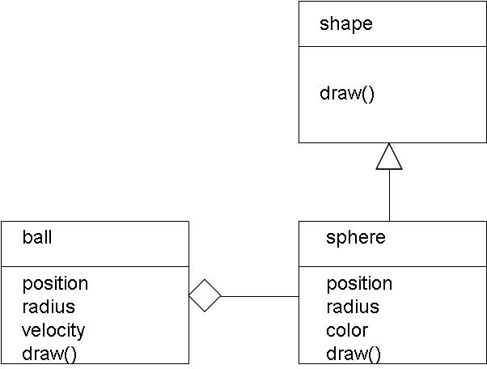

- The rest of the 3D world will be built out of immobile triangles. When the ball moves I need to detect collisions. Should collision detection be a responsibility of the ball class, the triangle class, or some other class? Justify you answer in terms of good design principles/heuristics.

